# CFSS CyberSecurity & Ethical Hacking Project

Name = Vineet Virendra Singh

Email = vineetvsingh12@gmail.com

QI. Vulnerabilities scanning:

1. Install Nessus on your system.
2. Perform a vulnerability scan on the Metasploitable machine using Nessus.

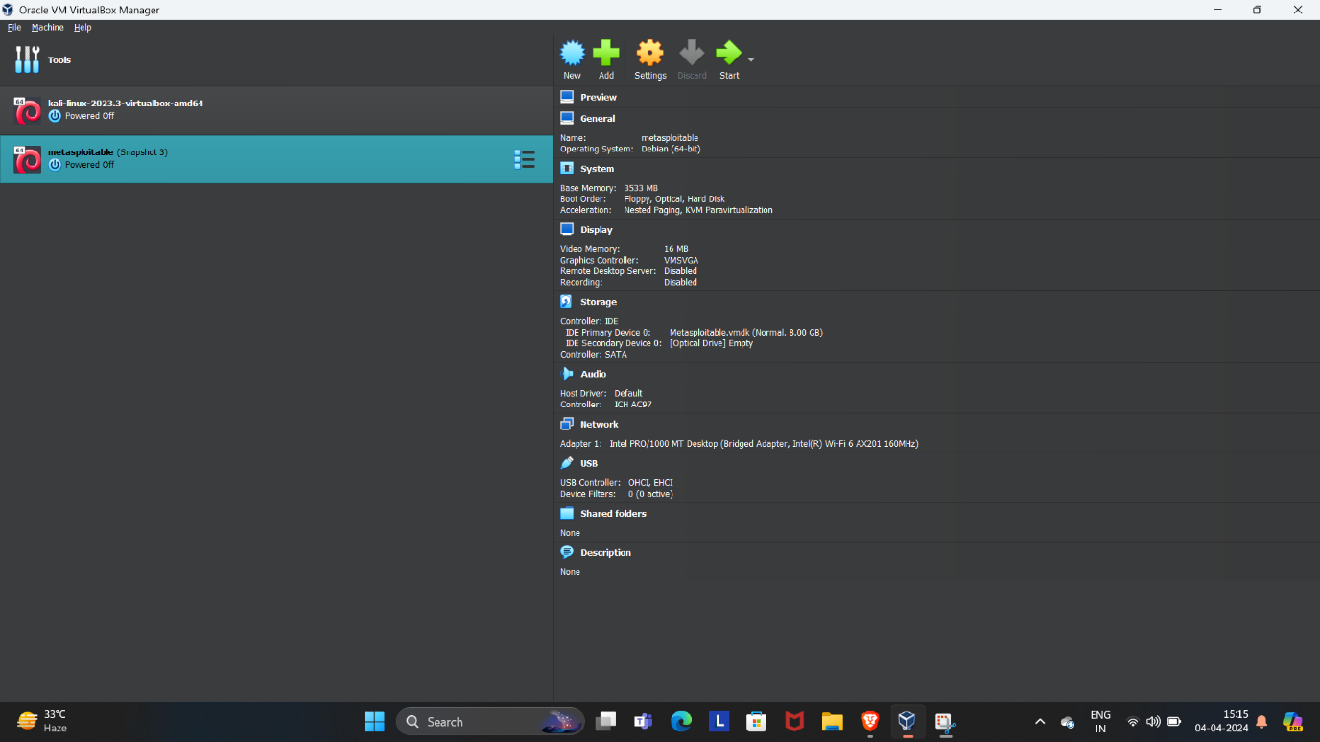

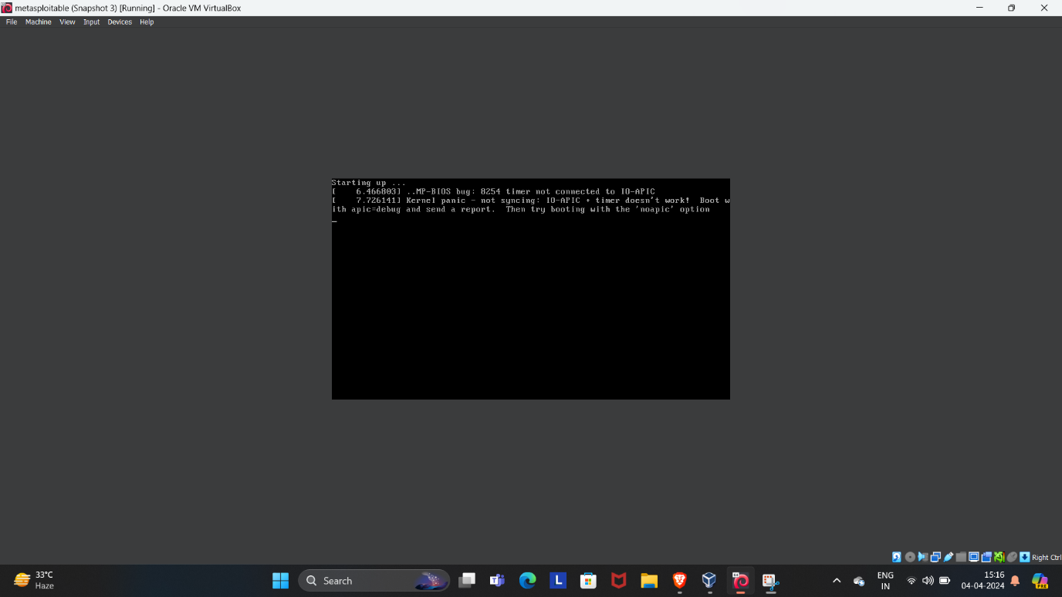

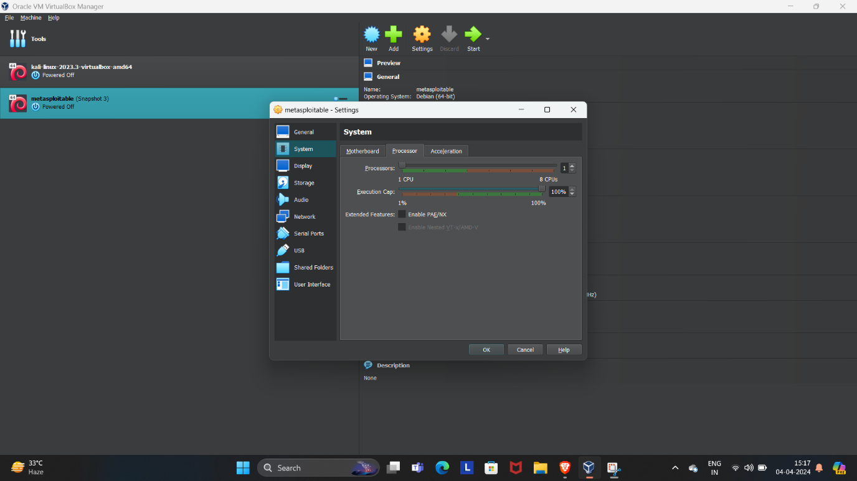

### Step 1: Install Nessus

1. **Download the Nessus Installer**: Visit the official Nessus website and download the appropriate installer for your operating system.
2. **Run the Installer**: Locate the downloaded file and run the installer with administrative privileges.
3. **Follow Installation Prompts**: Proceed through the installation wizard, accepting the license agreement and choosing the installation directory.
4. **Complete the Installation**: Finish the installation and launch Nessus.

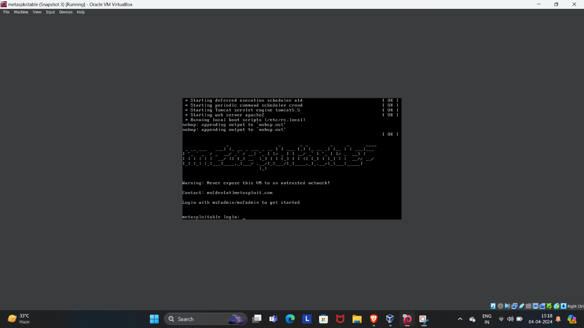

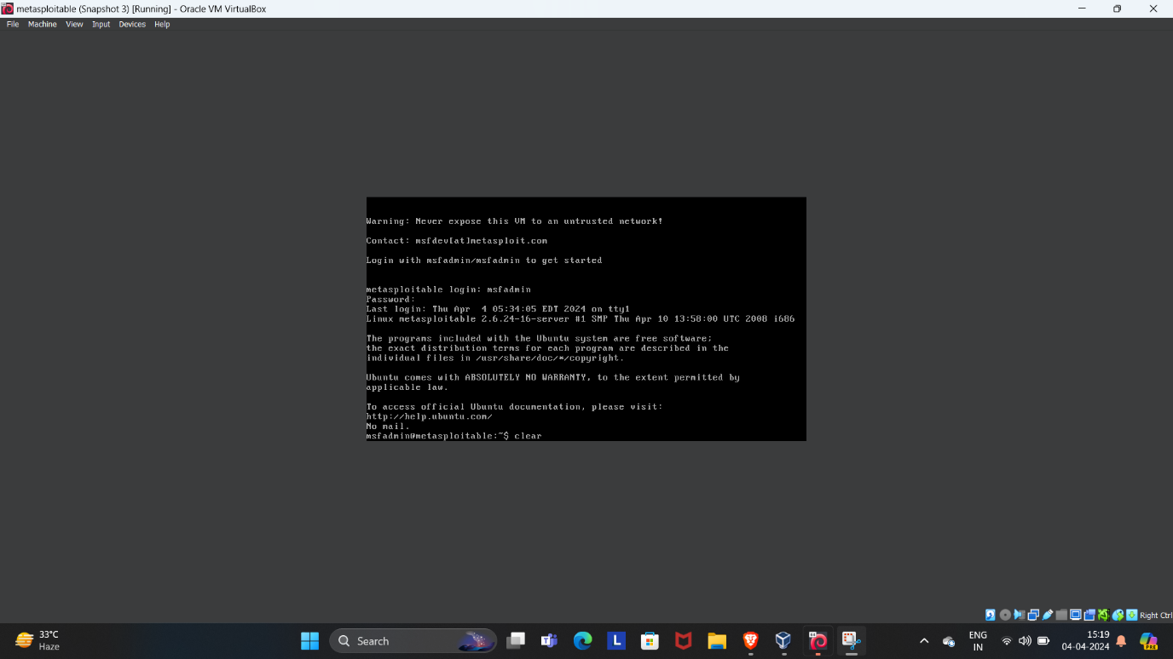

### Step 2: Set Up Nessus

1. **Access Nessus**: Open a web browser and navigate to https://localhost:8834 to access the Nessus web interface.
2. **Register Nessus**: Choose the Nessus Essentials (free version) and register by providing your details to receive an activation code via email.
3. **Activate Nessus**: Enter the activation code in the Nessus web interface to activate your product.
4. **Download Plugins**: Nessus will then download the necessary plugins, which may take some time depending on your internet connection.

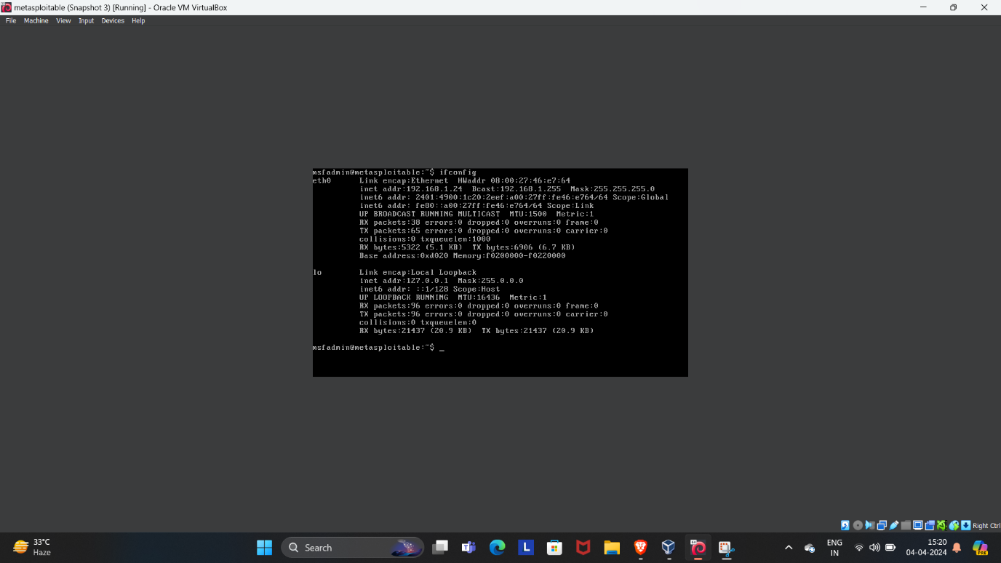

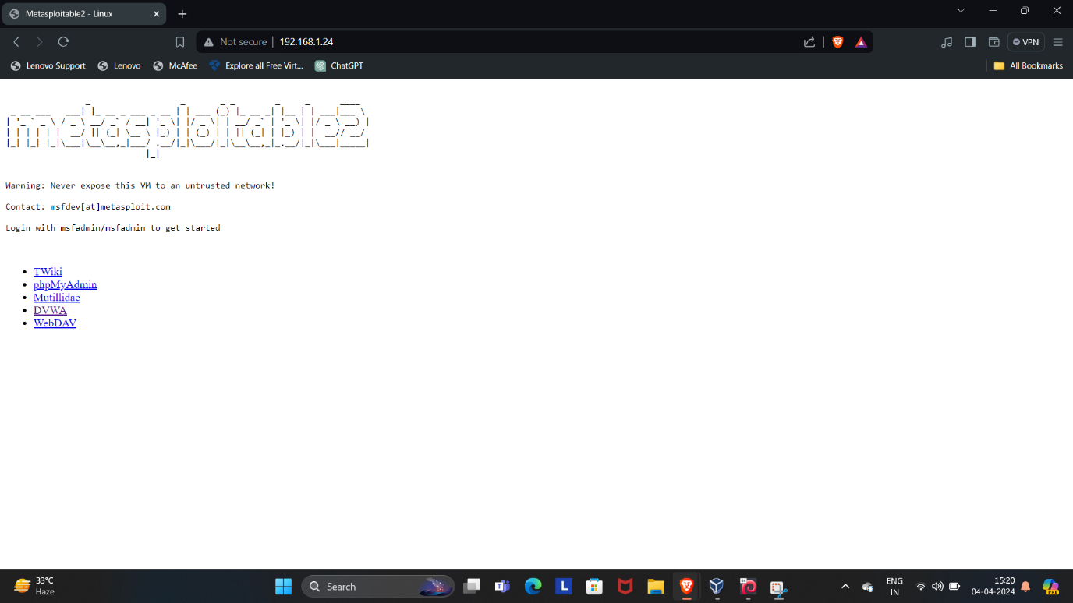

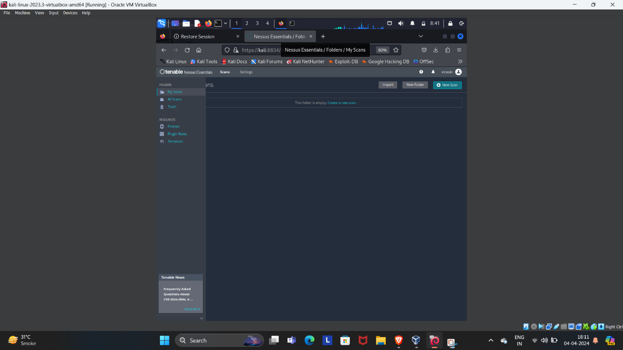

### Step 3: Perform a Vulnerability Scan

1. **Create a New Scan**: In the Nessus interface, click on ‘New Scan’ and select a scan template, such as ‘Basic Network Scan’.
2. **Configure Scan Settings**: Enter the name, description, and target IP address (the IP of the Metasploitable machine).
3. **Launch the Scan**: Save the configuration and launch the scan by clicking the ‘Play’ button.
4. **Monitor the Scan**: Wait for the scan to complete; this could take several minutes to hours depending on the network and settings.

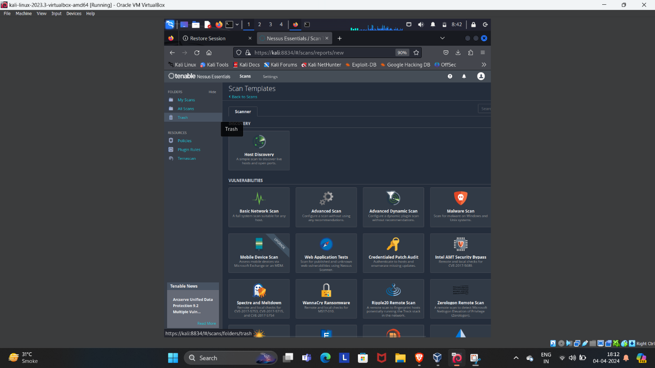

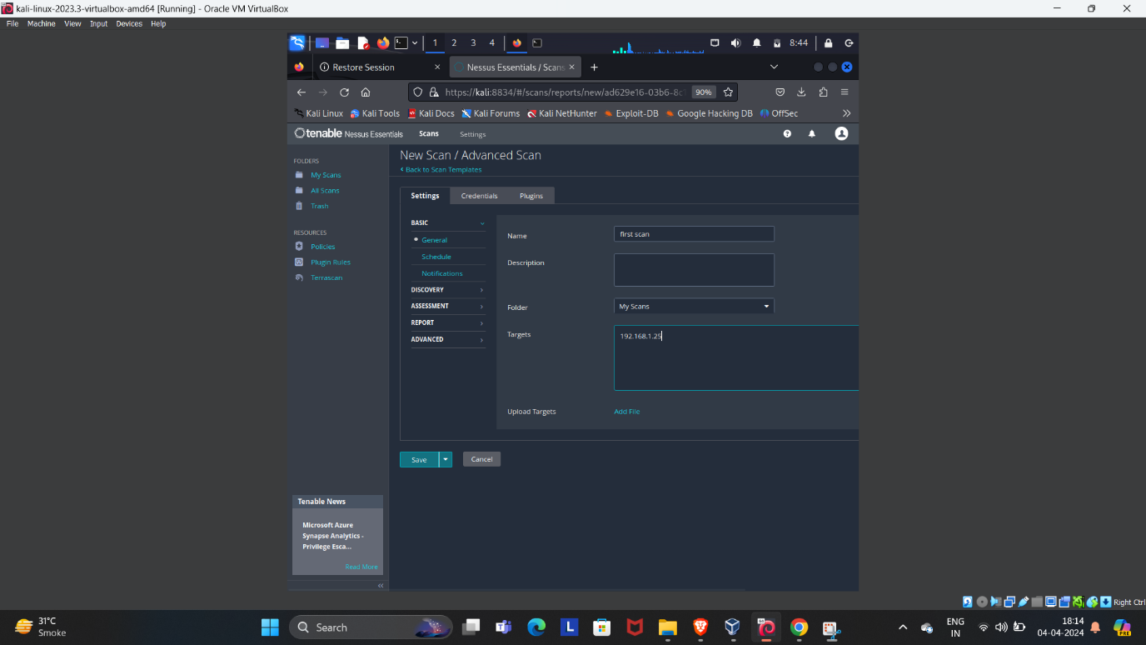

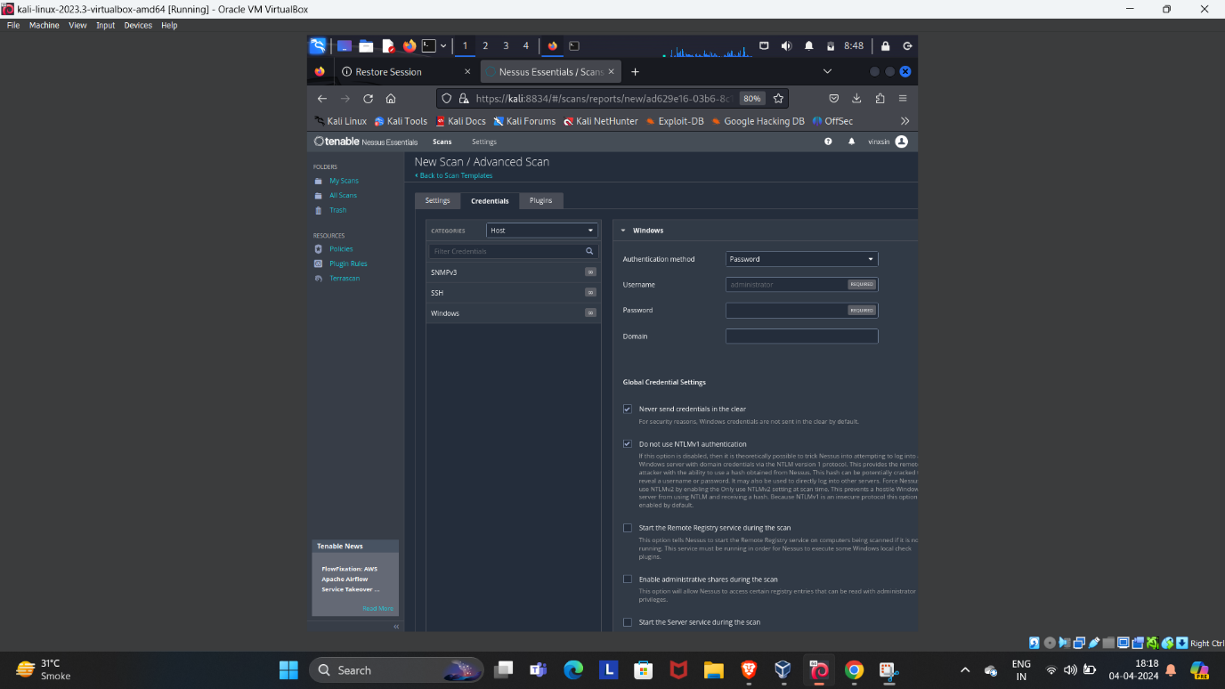

### Step 4: Review and Document Vulnerabilities

1. **Analyze the Results**: Once the scan is complete, review the list of identified vulnerabilities.
2. **Take Screenshots**: Capture screenshots of the vulnerabilities for documentation.
3. **Export the Report**: Optionally, you can export the scan results as a report in various formats for further analysis or sharing.

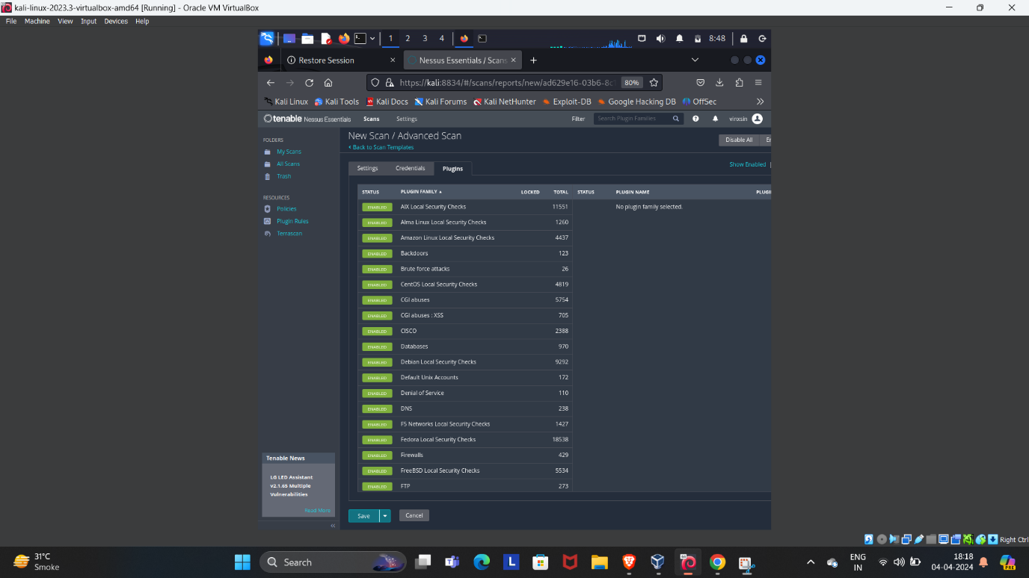

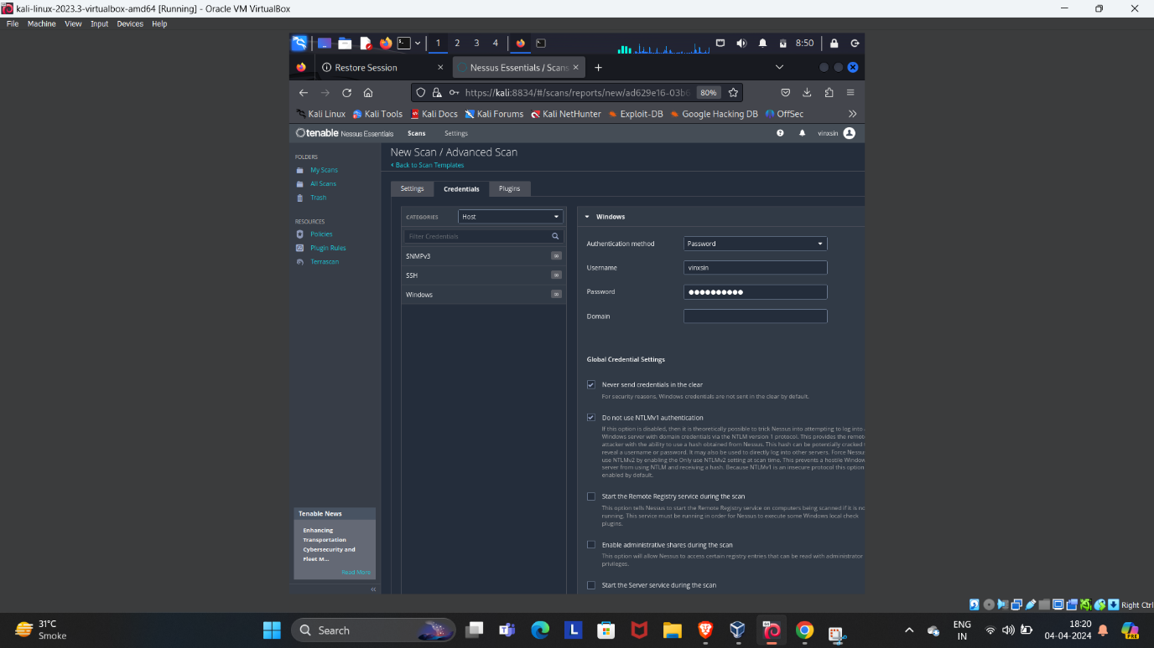

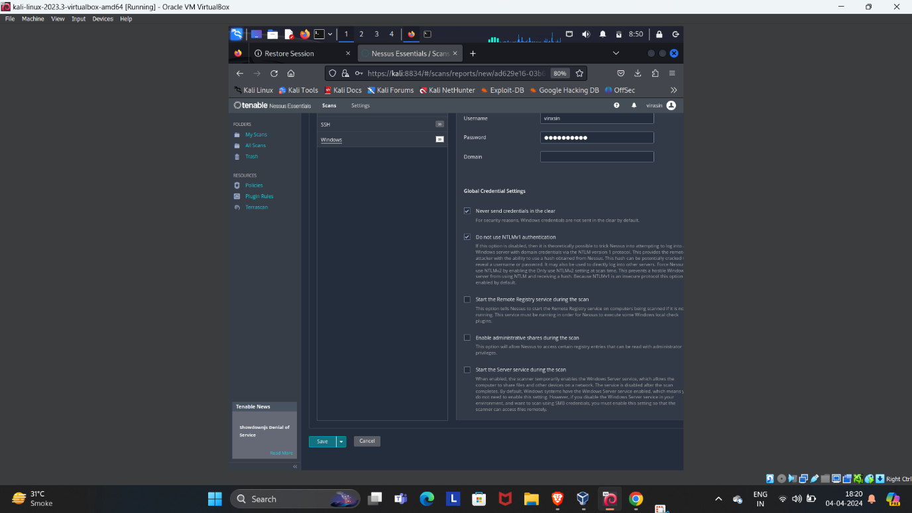

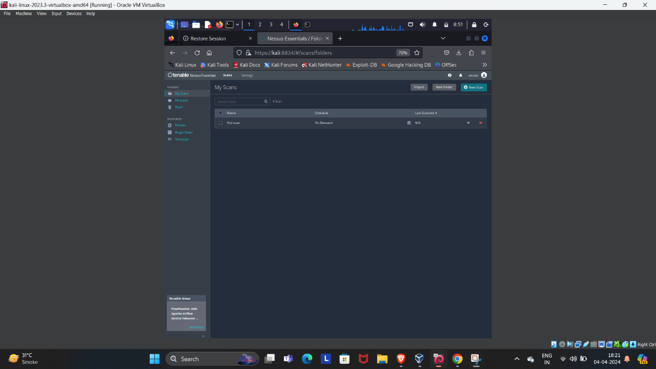

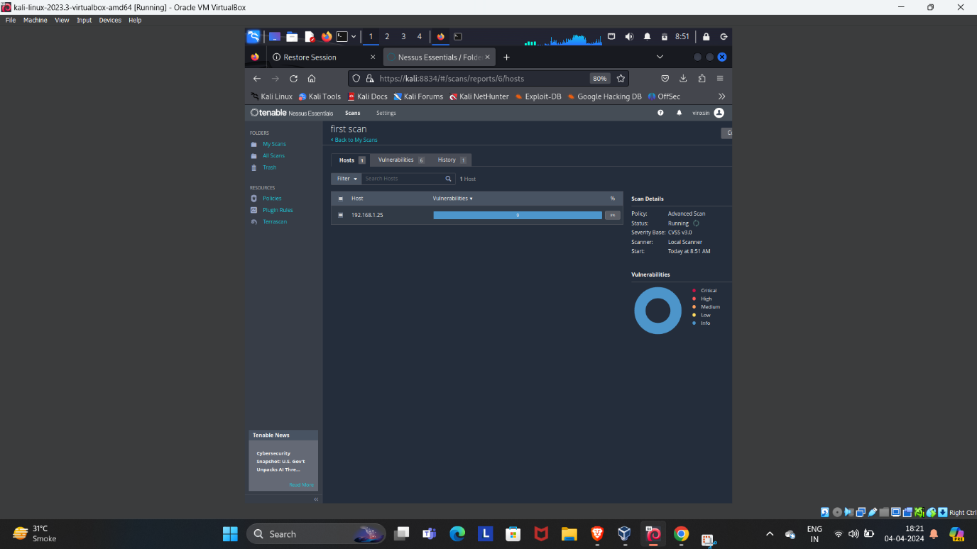

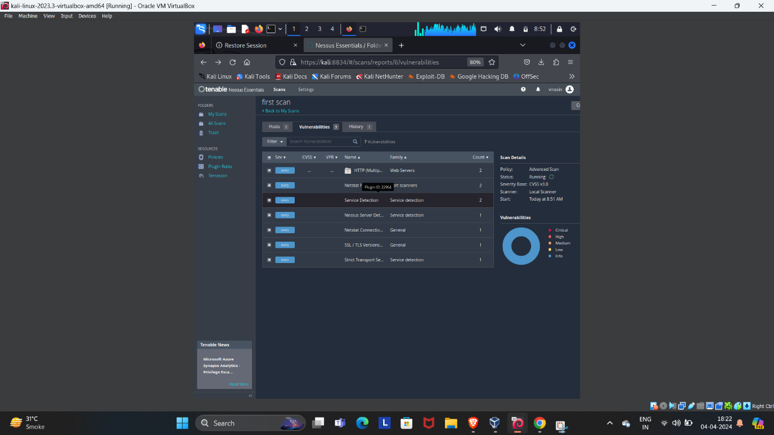

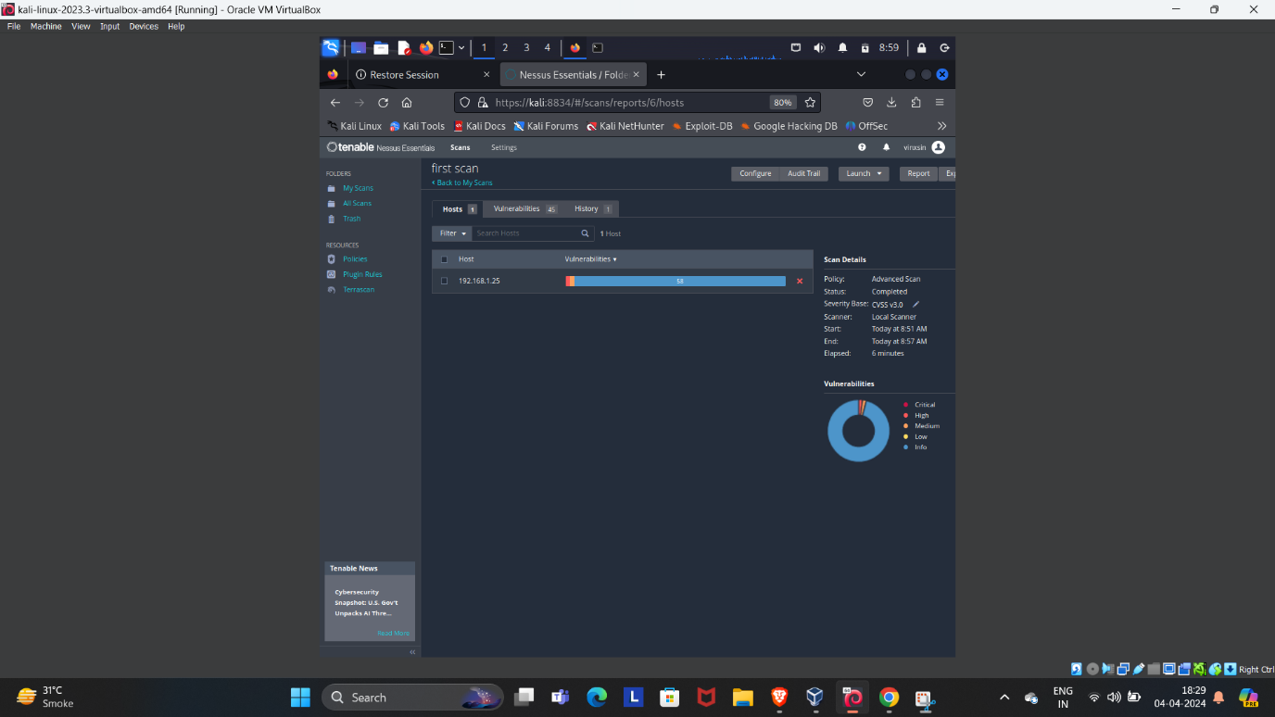

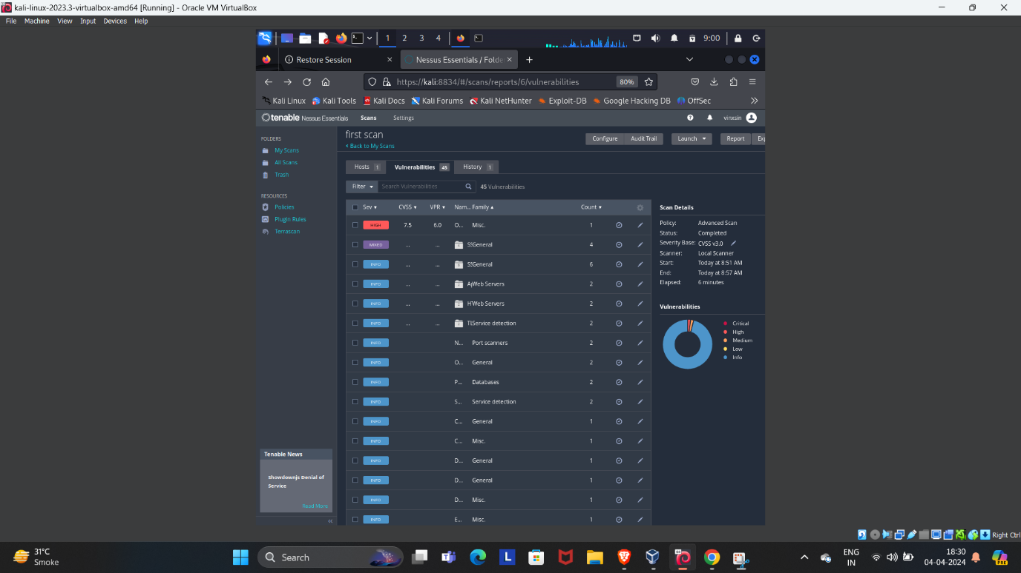

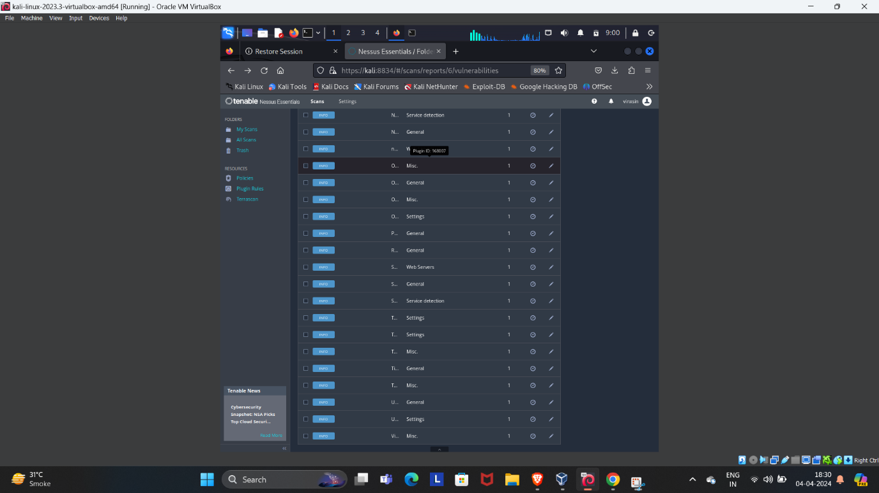

Remember to configure the scan settings according to the specific requirements of your environment and to handle the identified vulnerabilities responsibly. Always ensure that you have permission to scan the target system to avoid any legal issues

Q2. Utilize various tools such as Sublist3r and Maltego, along with the search engine Netcraft, to discover subdomains of the target 'bbc.com'.Additionally.

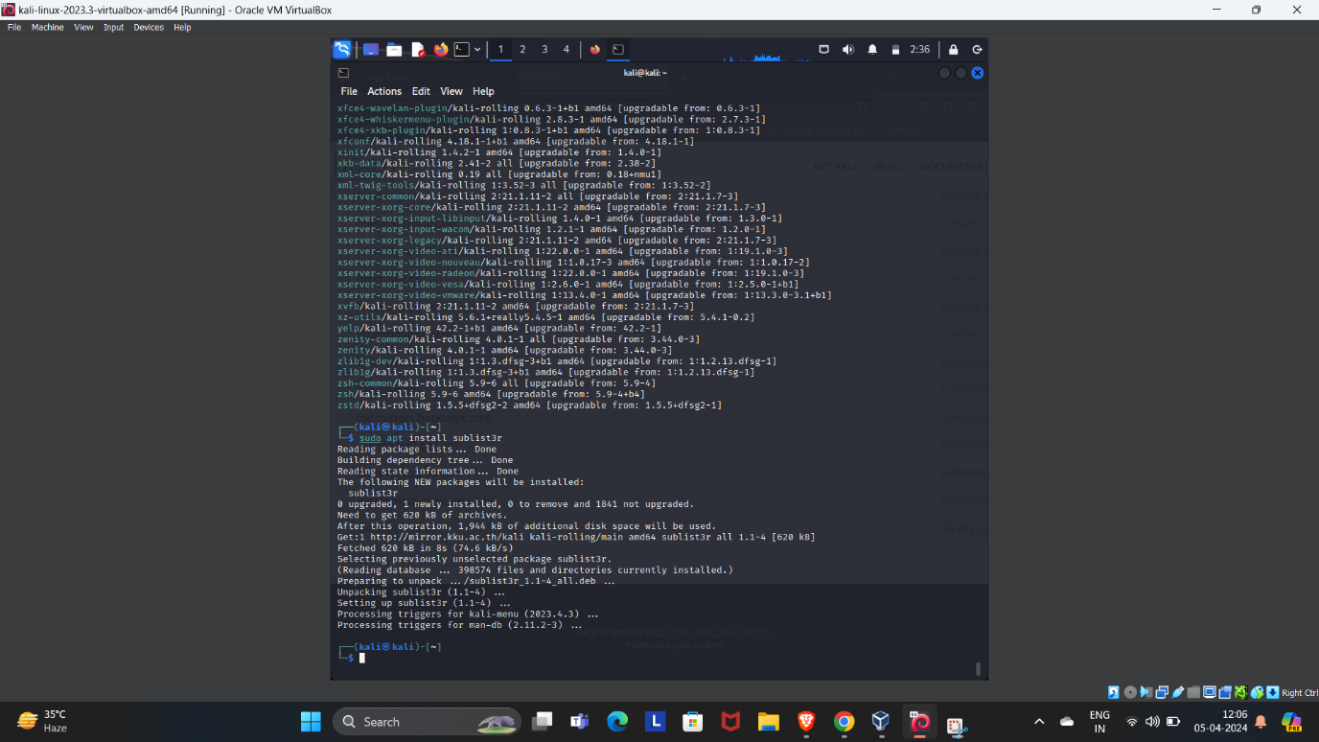



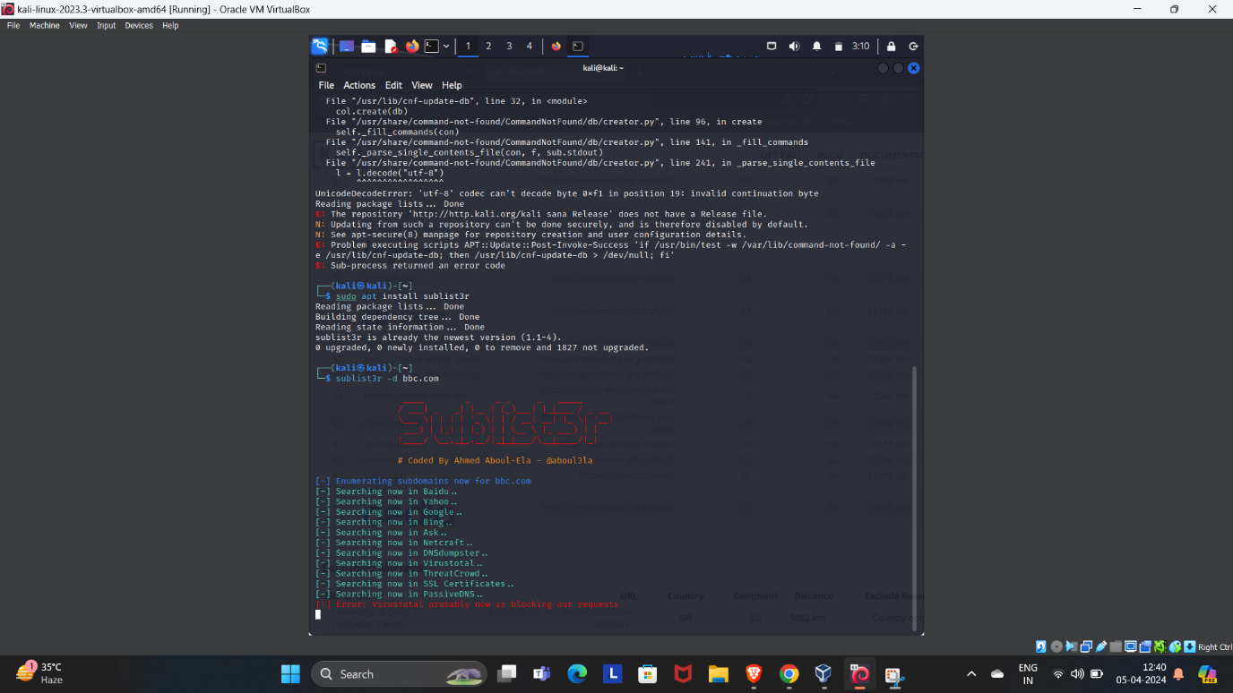



Certainly! Let’s break down the task of discovering subdomains of the target domain “bbc.com” using the mentioned tools: **Sublist3r**, **Maltego**, and **Netcraft**.

### 1. Sublist3r:

**Sublist3r** is a Python tool designed for subdomain enumeration using open-source intelligence (OSINT). It leverages various search engines and data sources to collect subdomains related to a target domain. Here’s how to use it:



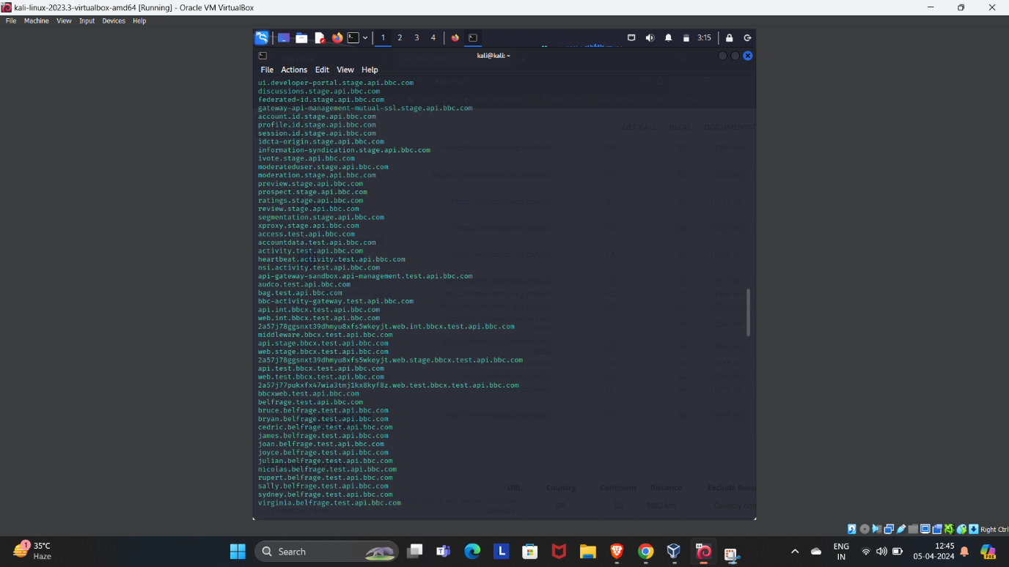



1. **Installation**:
   * Clone the Sublist3r repository from GitHub: git clone https://github.com/aboul3la/Sublist3r.git
   * Navigate to the Sublist3r directory: cd Sublist3r
   * Install required dependencies: pip install -r requirements.txt



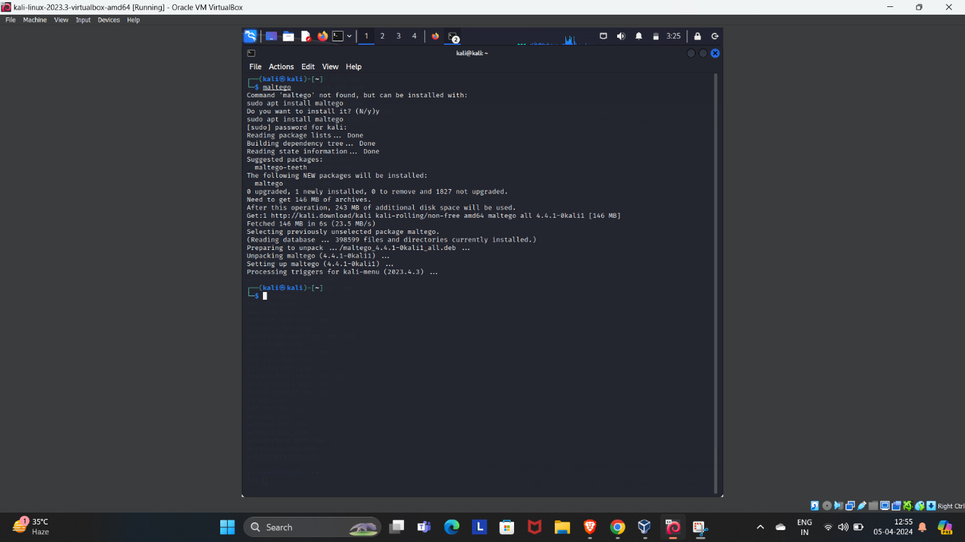

1. **Run Sublist3r**:
   * Execute the following command in the terminal:
   * ./sublist3r.py -v -d bbc.com -t 5 -e bing -o ~/Desktop/subresult.txt
     + -v: Verbose output
     + -d bbc.com: Specify the target domain
     + -t 5: Use 5 threads
     + -e bing: Use Bing as the search engine
     + -o ~/Desktop/subresult.txt: Save results to a file on the desktop
2. **Results**:
   * Sublist3r will list all discovered subdomains related to “bbc.com.”

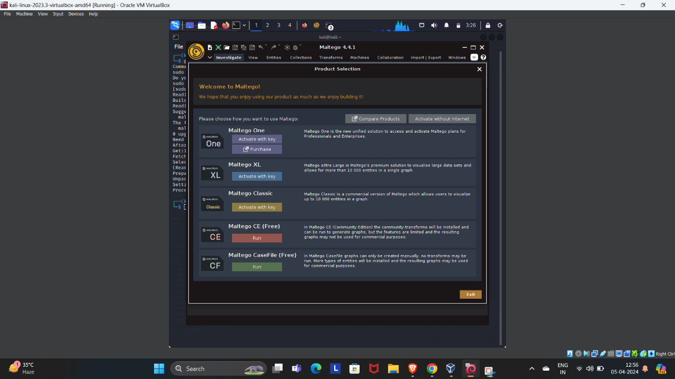

### 2.Maltego:

**Maltego** is a powerful link analysis tool that visualizes connections within complex data sets. It’s particularly useful for OSINT and penetration testing. Here’s how to use it:



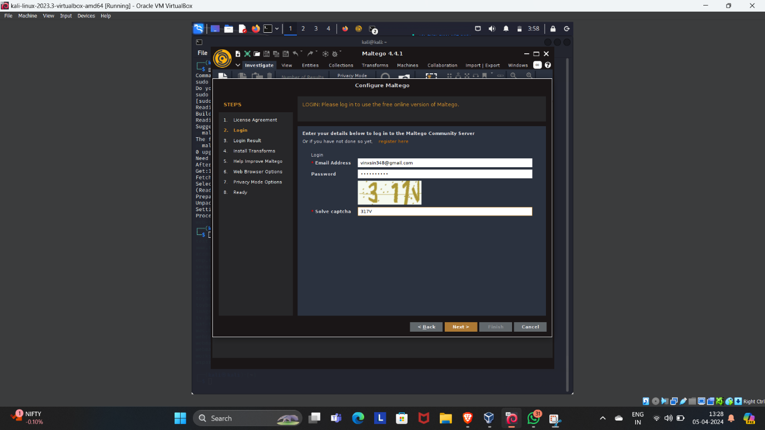

1. **Installation**:
   * Install Maltego on your preferred platform (e.g., Kali Linux, Windows, macOS).
   * Run the installer and configure Maltego.
2. **Start Maltego**:
   * Open Maltego from the terminal or application menu.
   * Select the “Maltego CE (Free)” version.

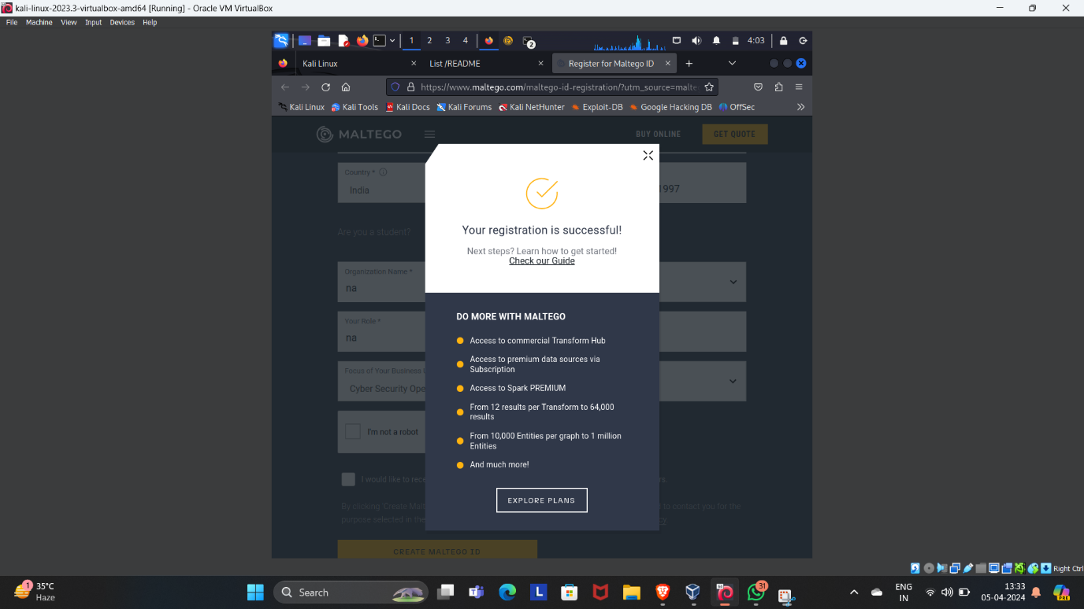

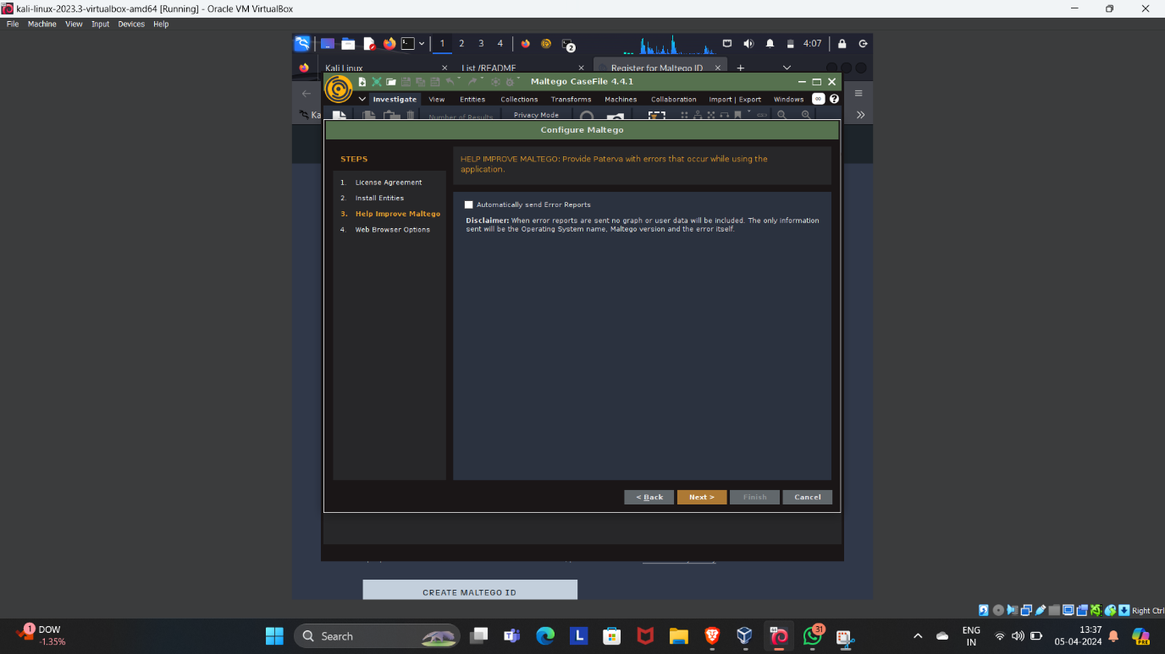

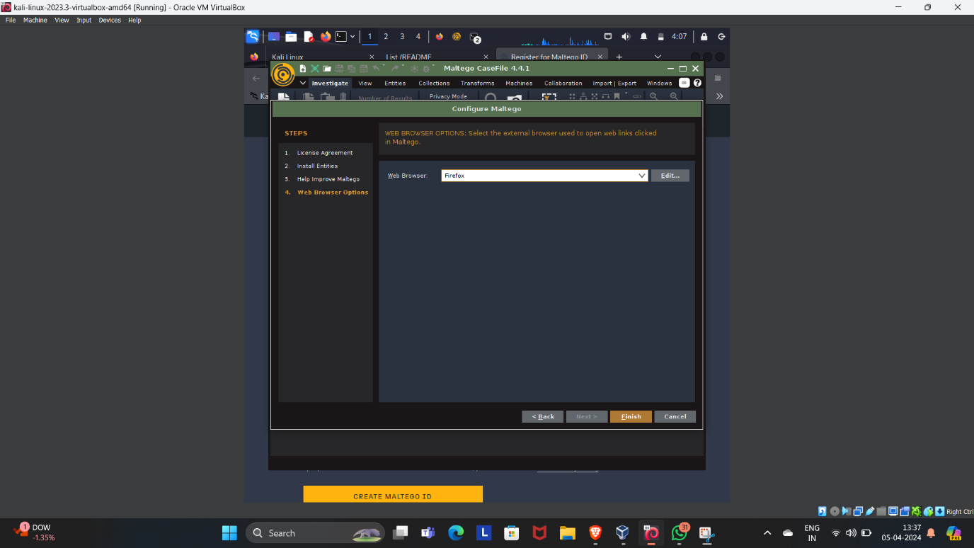

1. **Configure Maltego**:
   * Accept the license agreement.
   * Log in or register for an account.
2. **Using Maltego Transforms**:
   * Enter the target domain (bbc.com) in the search box.
   * Use Maltego’s Transforms to uncover hidden relationships within data sets.
   * Explore connections related to domains, IP addresses, social media profiles, etc.



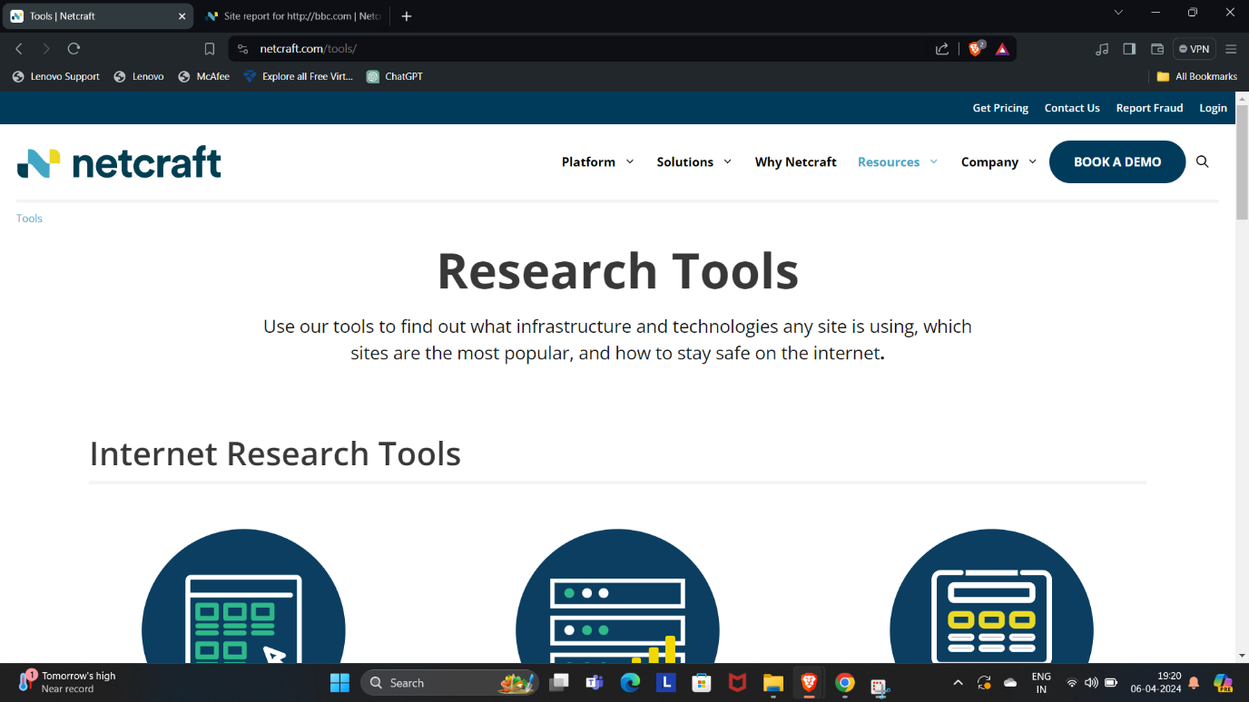

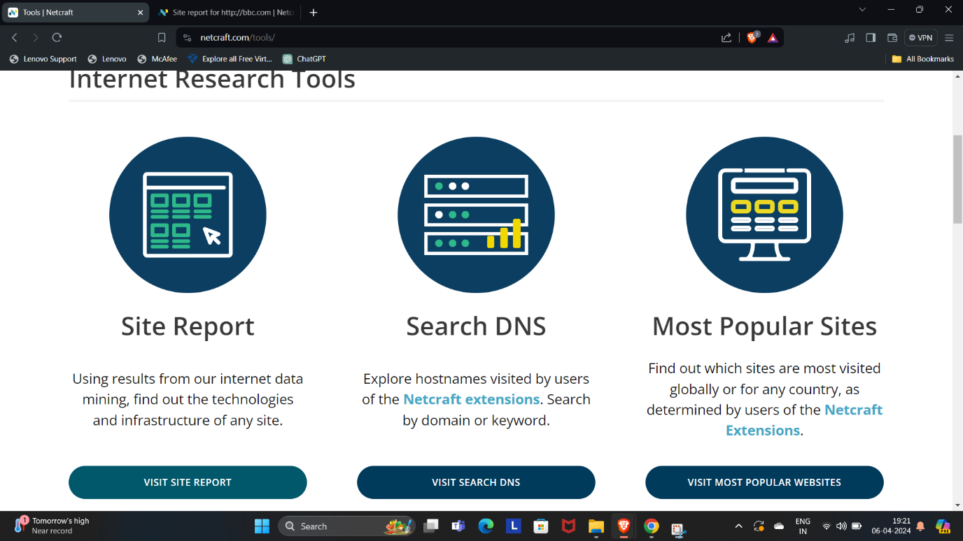

### 

### 3.Netcraft:

**Netcraft** provides a search tool to explore websites visited by users of the Netcraft extensions. Here’s how to use it:

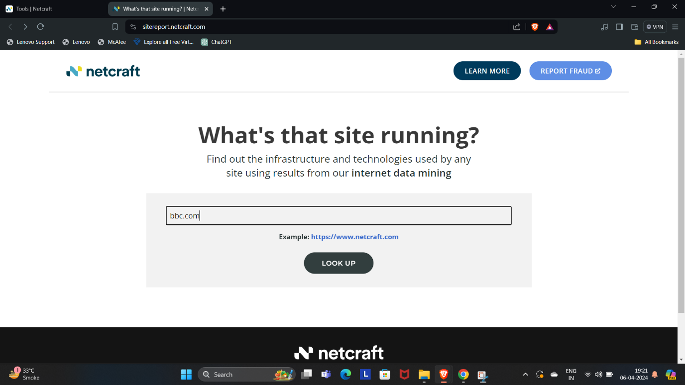

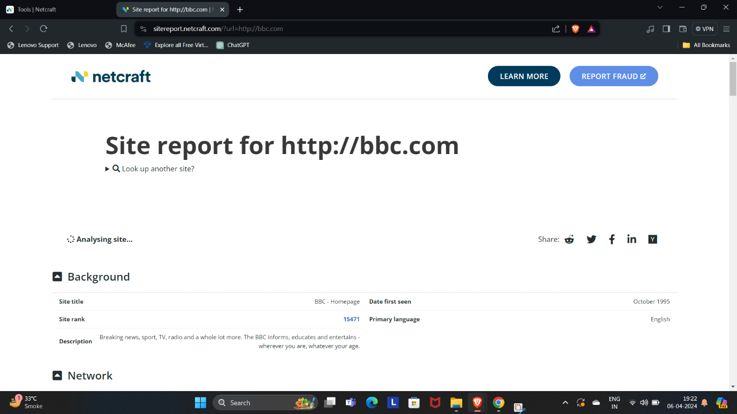

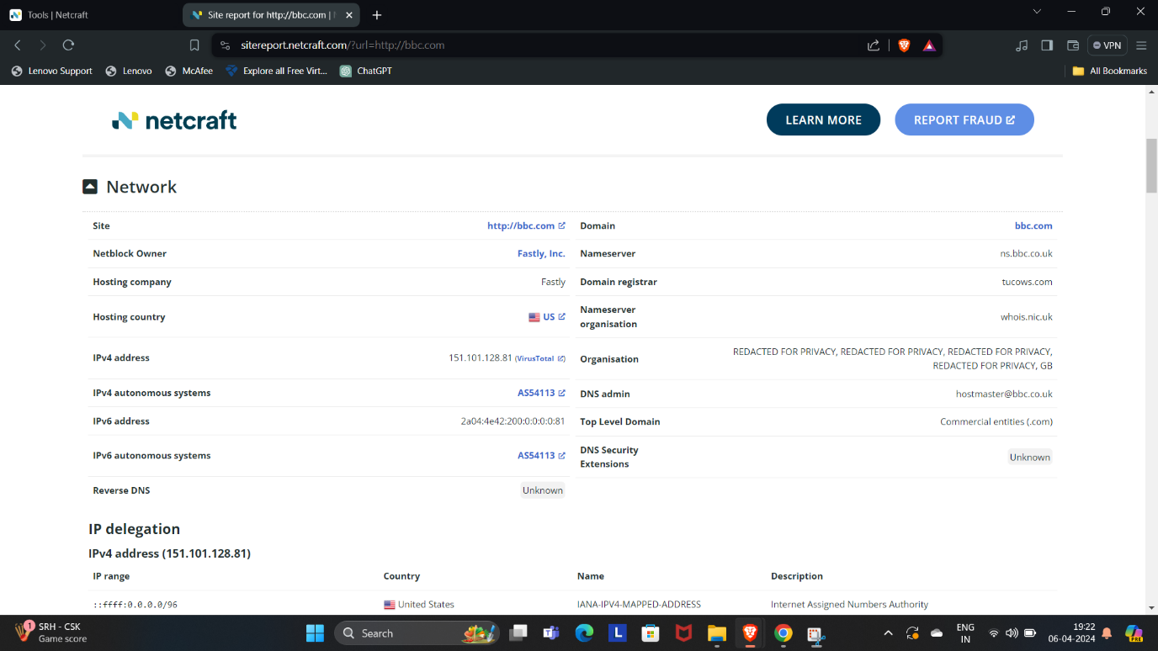

1. **Access Netcraft’s Site Report Tool**:
   * Go to [Netcraft’s Site Report tool](https://sitereport.netcraft.com/).
2. **Enter the Target Domain**:
   * Enter “bbc.com” in the search box and click “Lookup.”
   * Netcraft will generate a report on the company’s website.

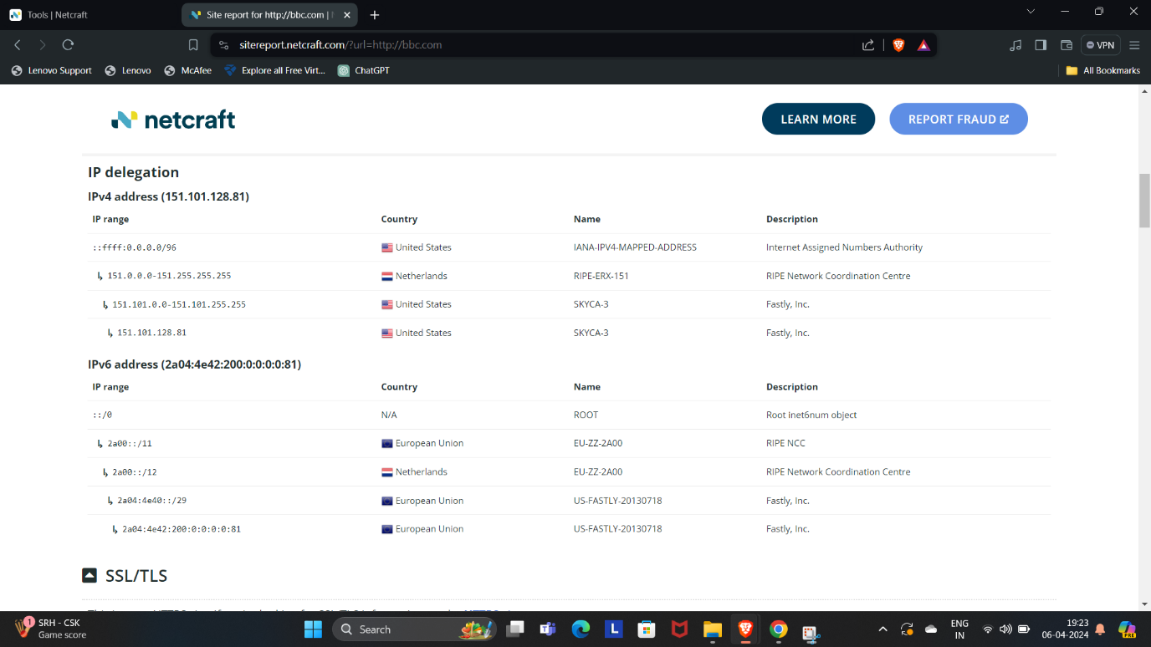

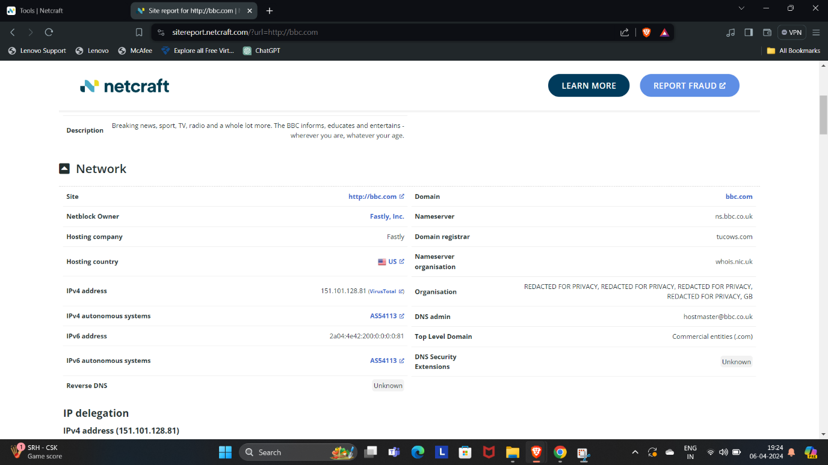

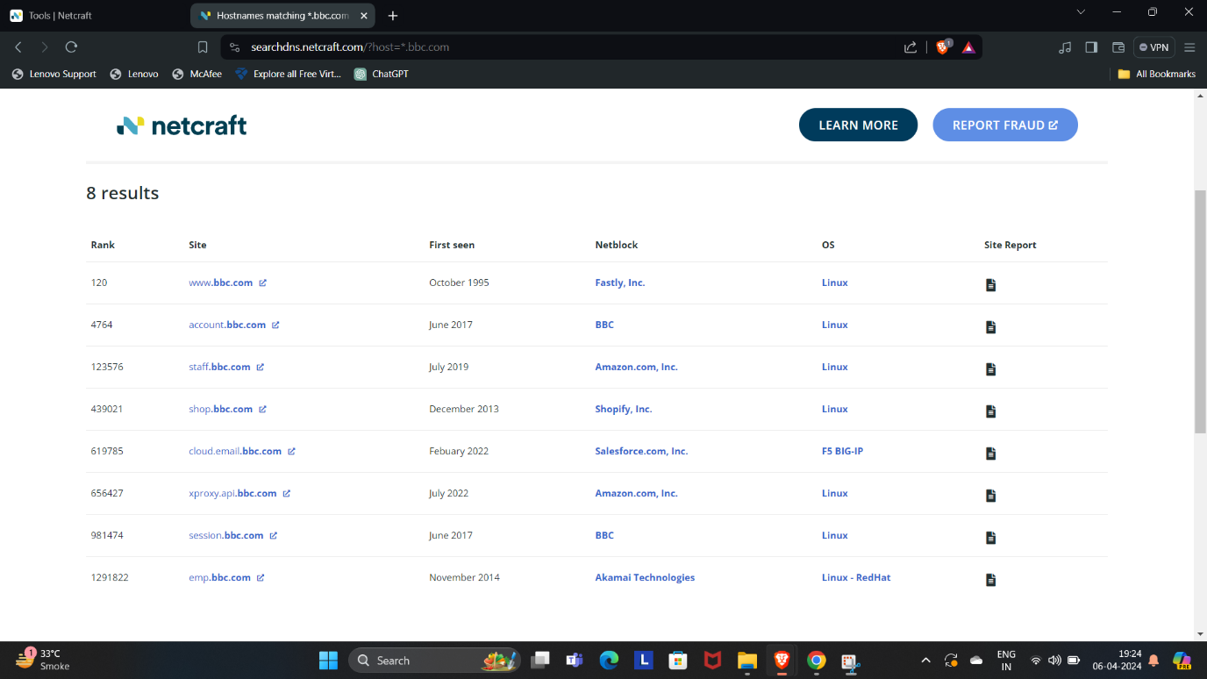

1. **View Subdomains**:
   * In the Network section, click on the website link (bbc.com) in the Domain field.
   * The result will display subdomains of the target website along with netblock and operating system information.

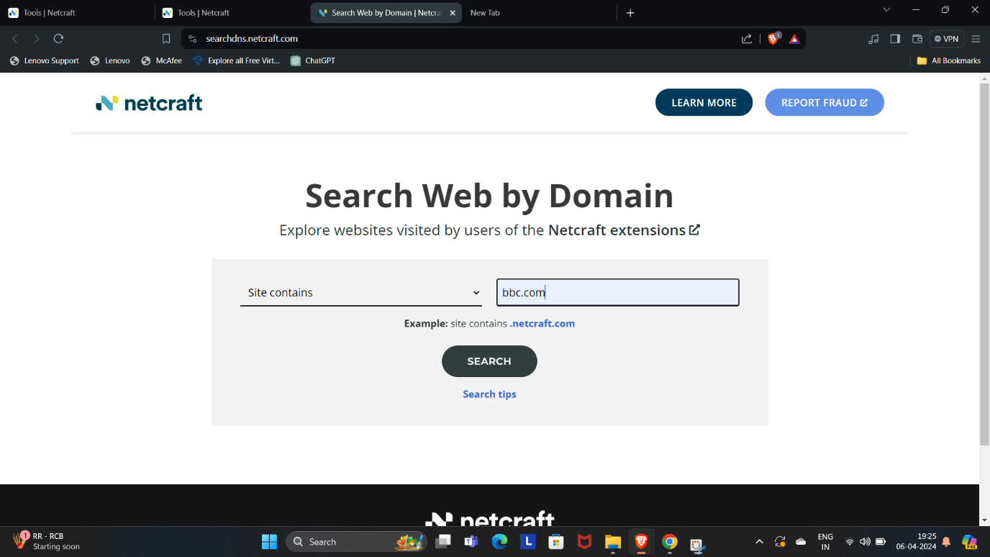

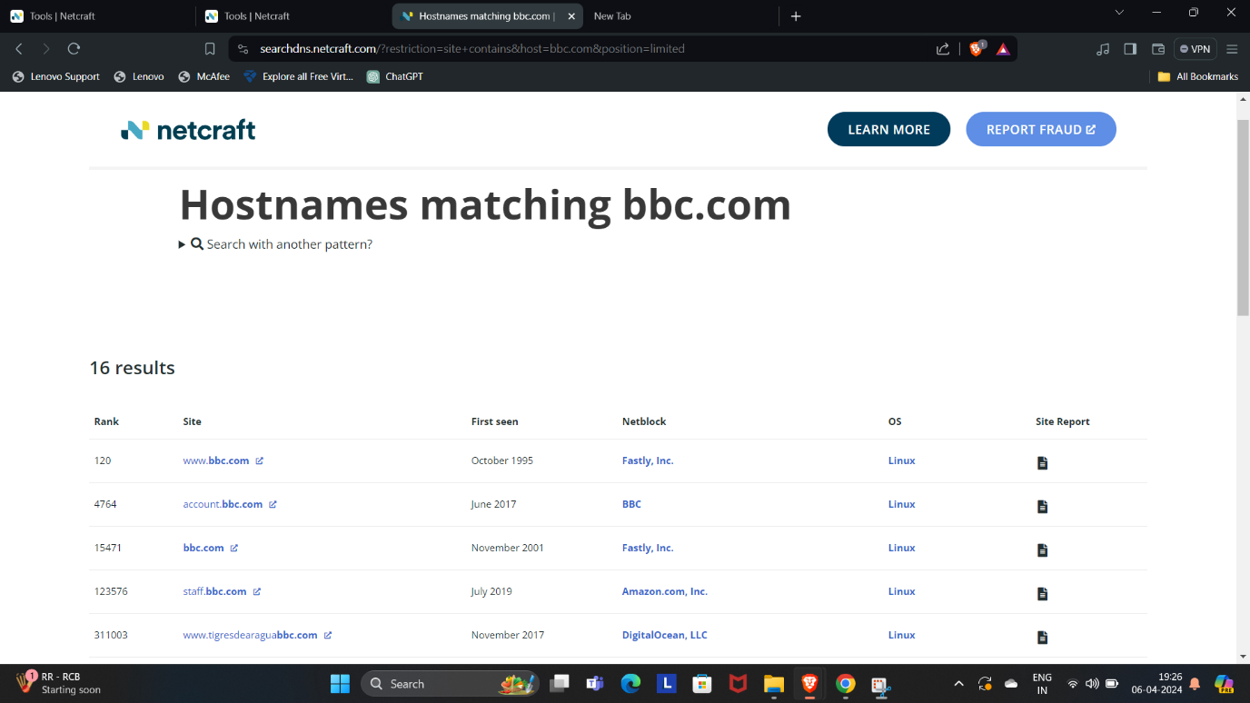

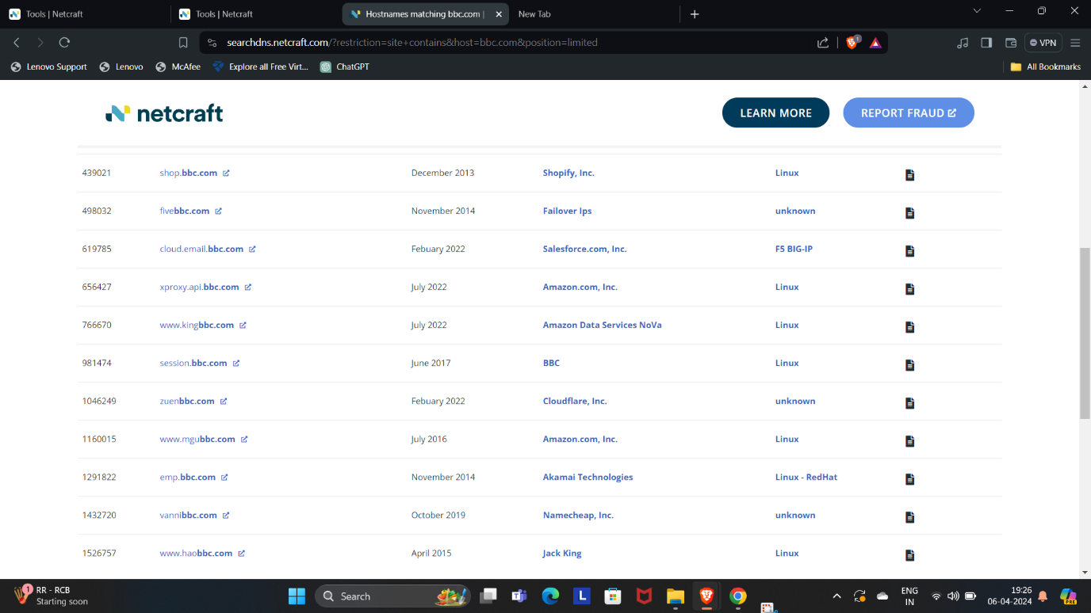

Remember that attackers can use the collected list of subdomains for various purposes, including web application attacks. Always use these tools responsibly and with proper authorization

Q3. Explain what the Wayback Machine is and how it functions. Describe the process of retrieving sensitive data from the Wayback Machine. Provide a screenshot of how the website 'bbc.com' appeared in 2010, obtained from the Wayback Machine.

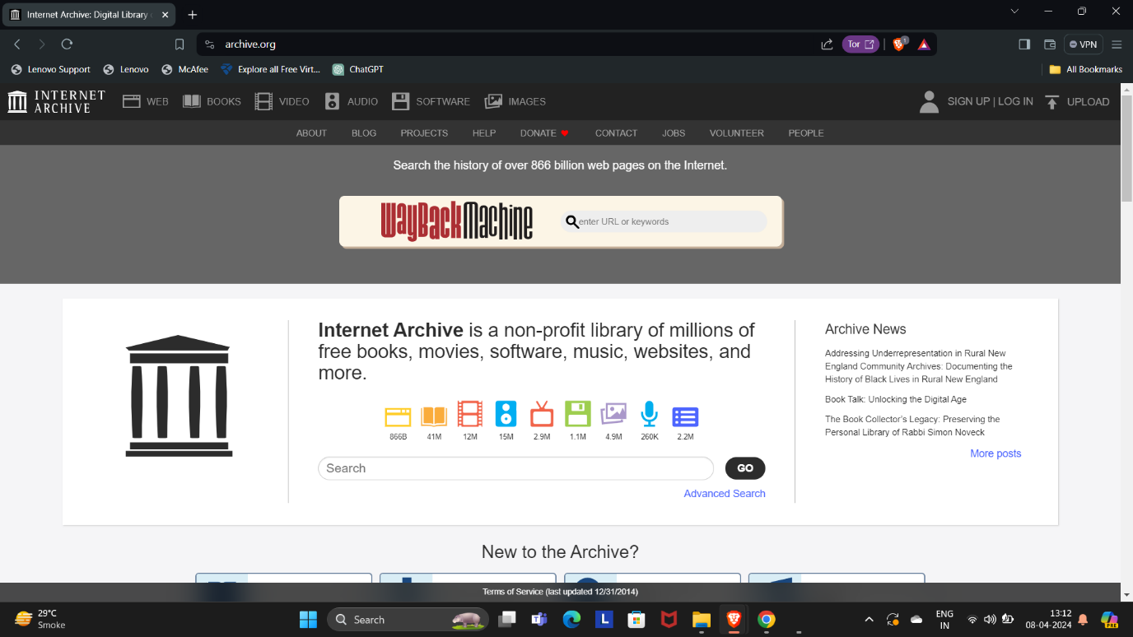

### What Is the Wayback Machine?

The **Wayback Machine** is a digital archive of the World Wide Web founded by the **Internet Archive**, a nonprofit organization based in San Francisco, California. Created in 1996 and launched to the public in 2001, it allows users to “go back in time” and view historical versions of websites.

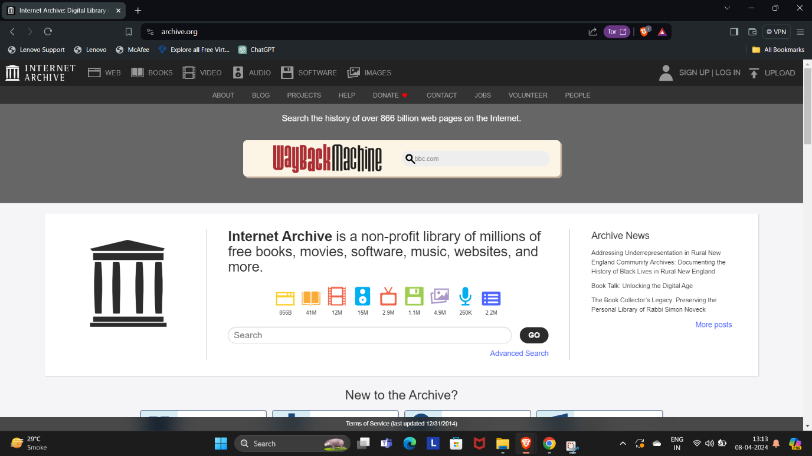

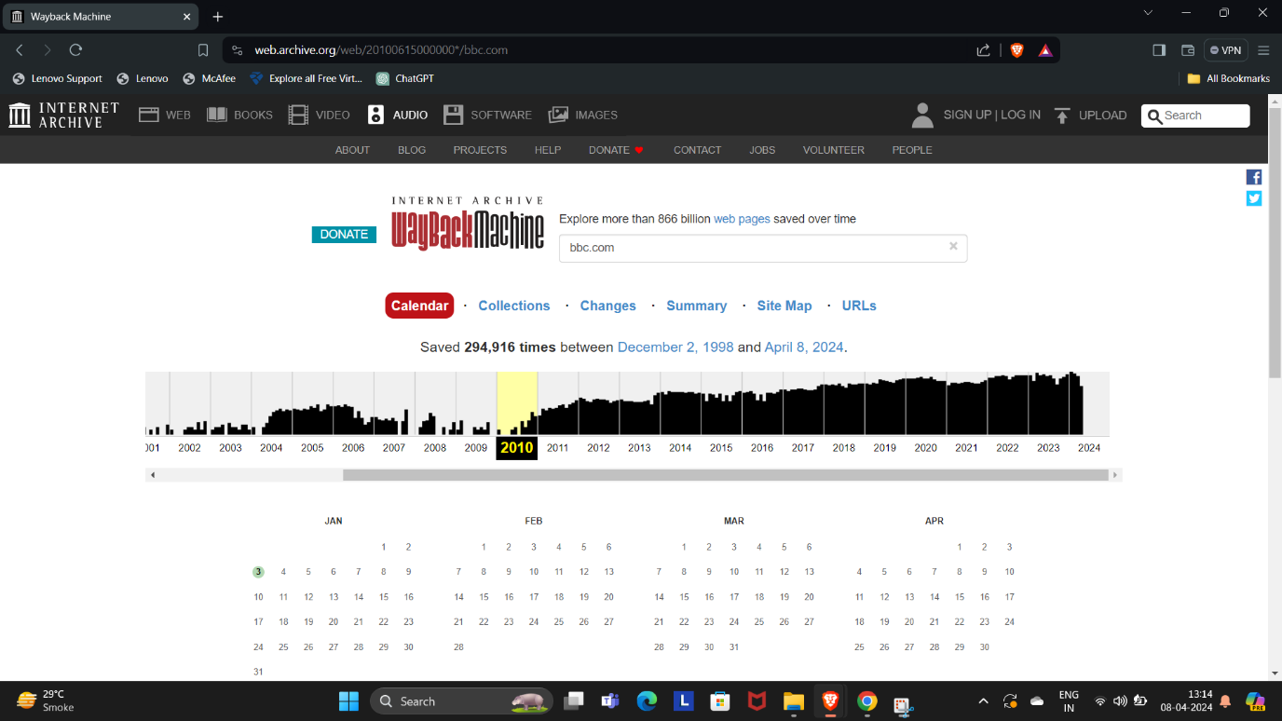

### How Does the Wayback Machine Function?

1. **Archiving Process**:
   * The Wayback Machine regularly **crawls** the web, taking **snapshots** of websites at different time intervals.
   * These snapshots are then **archived**, preserving the Internet’s history.
   * The archived sites represent a kind of “snapshots” collected by the Internet Archive indexing software.
2. **Accessing Archived Versions**:
   * Users can visit the Wayback Machine website and enter a URL.
   * They can then select a specific **date range** and explore an archived version of the webpage from that time.
   * The Wayback Machine provides a way to view how websites looked in the past.
3. **Preserving Internet History**:
   * The Wayback Machine is crucial for **preserving the history of the Internet**.
   * It allows researchers, journalists, and curious users to access older versions of websites and track changes over time.

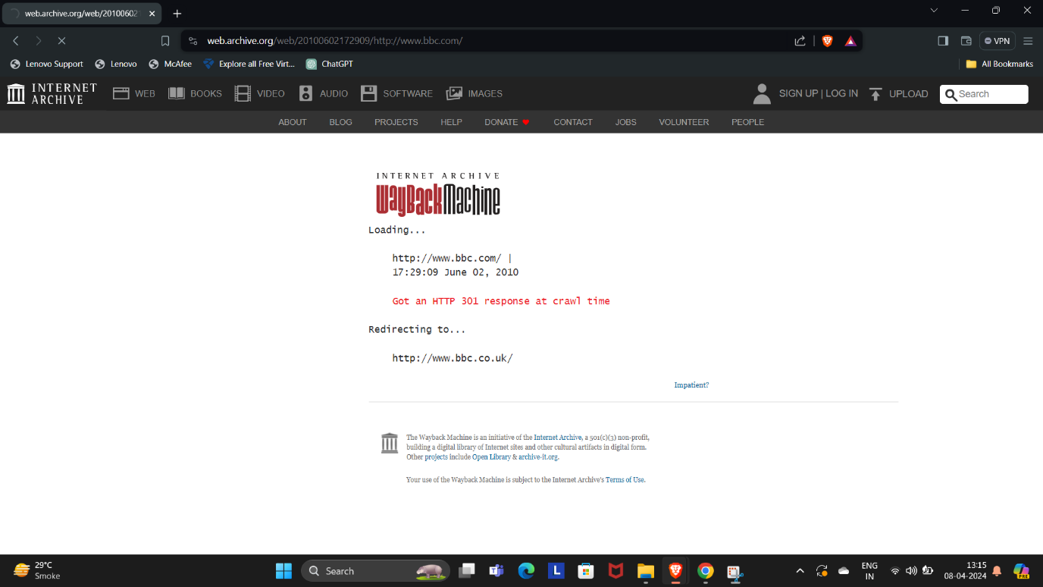



### Retrieving Sensitive Data from the Wayback Machine:

1. **Identify the Target URL**:
   * Locate the specific webpage or website you want to retrieve data from.
   * Note the original URL and the date you want to access.
2. **Use the Wayback Machine**:
   * Visit the [Wayback Machine website](http://wayback.archive.org/).
   * Enter the target URL and select the desired date range.
3. **Explore the Archived Version**:
   * The Wayback Machine will display the archived version of the webpage.
   * You can navigate through the content, including text, images, and other media.

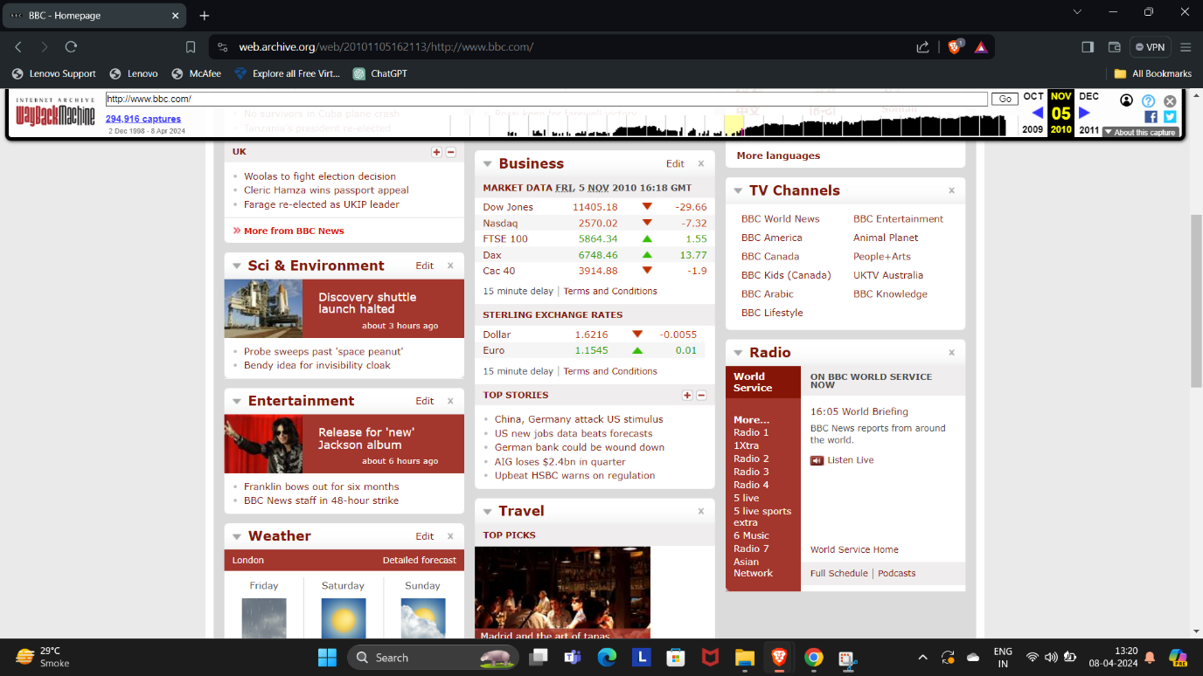

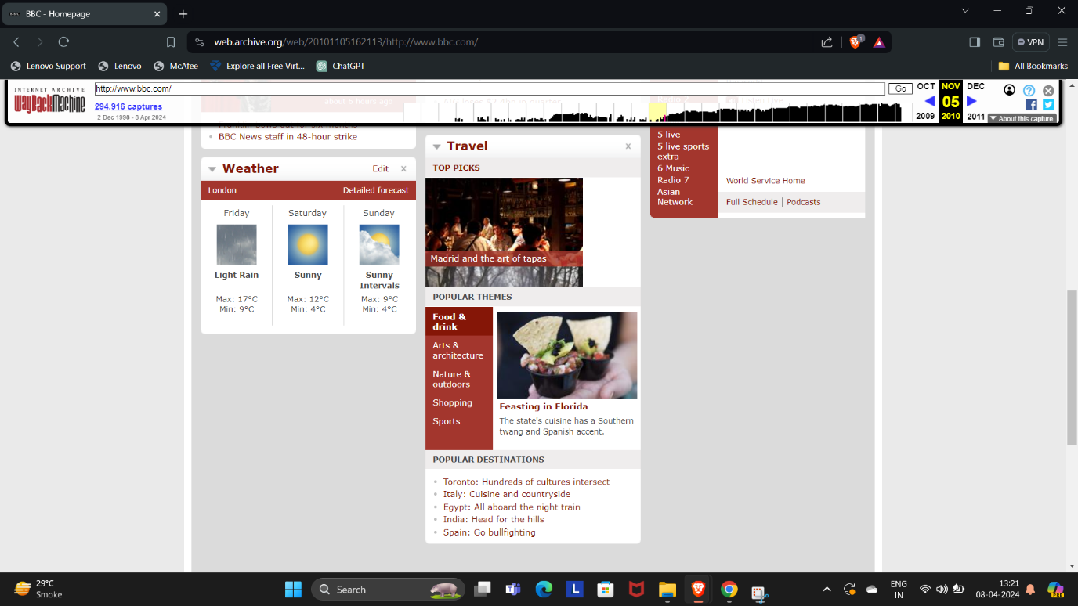

**4.Check for Sensitive Data**:

* + Examine the archived content for any sensitive information.
  + Be cautious about personal details, confidential data, or anything that could cause harm if exposed.

**5.Save or Document**:

* + If you find relevant data, save it or document it for your records.
  + Remember that the Wayback Machine captures static content; dynamic server-side logic may not be recoverable.

**6.Repeat as Needed**:

* + If the archived version lacks certain details, explore other snapshots or dates.
  + Repeat the process until you retrieve the necessary information.

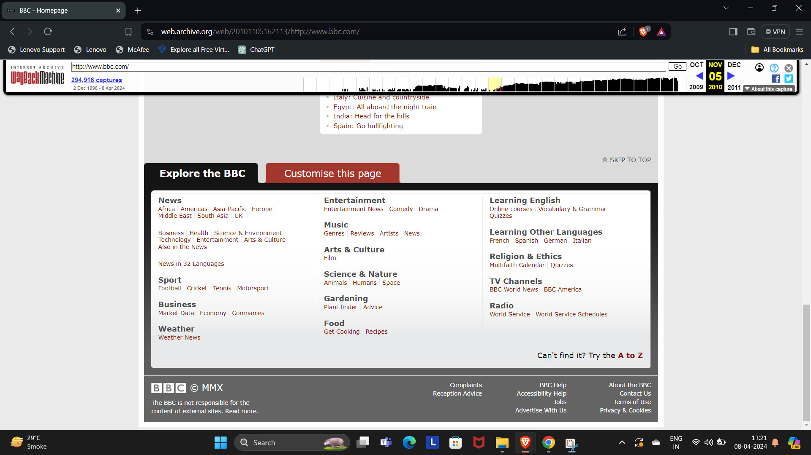

Remember that while the Wayback Machine is a powerful tool, its legality varies across countries, and some content may be removed or restricted.

Q4. Establish a connection to a local area network (LAN) via Wi-Fi. Utilize the

NMAP tool to determine the number of devices currently connected to the LAN. Please include the specific command you used for this task and provide a screenshot of your terminal showing the results.

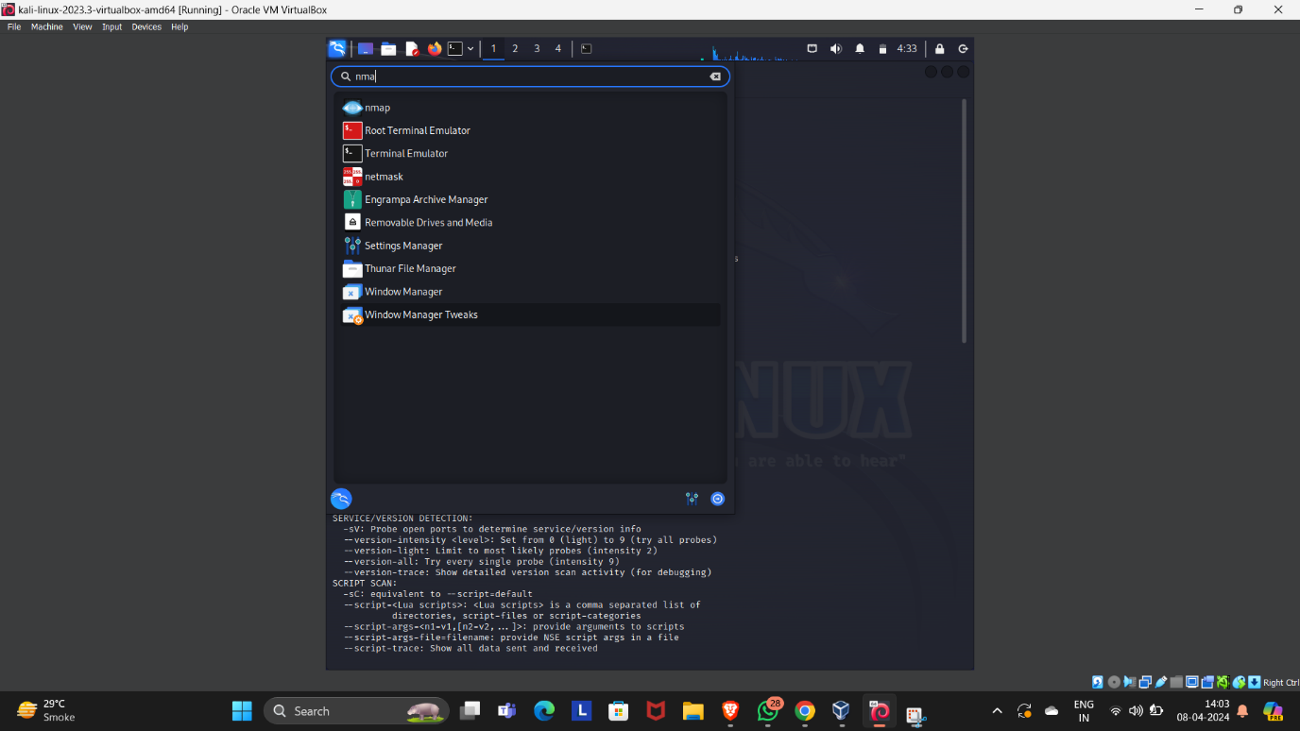

### Connecting to a LAN via Wi-Fi:

1. **Wireless Access Point (WAP)**:
   * To create a LAN network for wireless users, you’ll need a **Wireless Access Point (WAP)**.
   * Configure the WAP by setting its IP address, wireless parameters (SSID, security settings), and DHCP server.
   * Ensure that clients connecting to the WAP have their Wi-Fi parameters configured (SSID, security protocol) and are set to receive DHCP addresses.
   * Once configured, you’ve created a LAN network using Wi-Fi for wireless users.

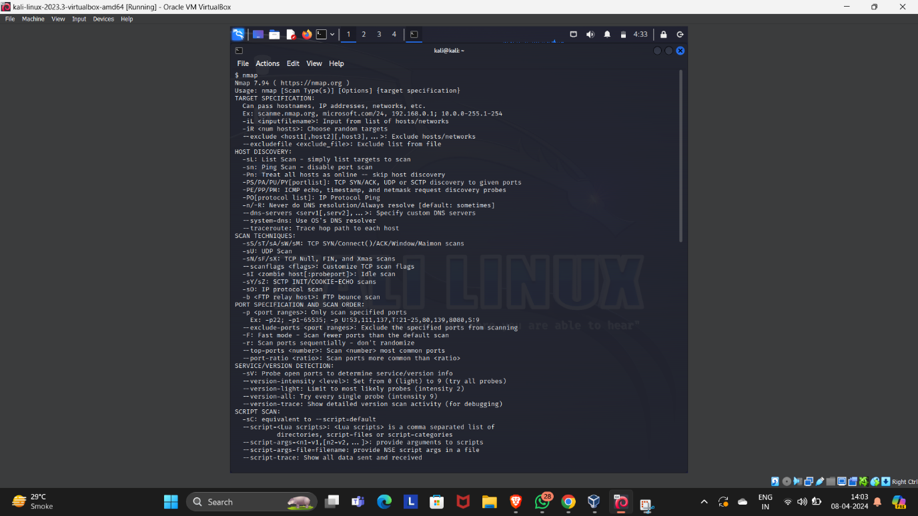

**2.Combining Wired and Wireless Users**:

* + If you have both wired and wireless users (e.g., desktops and mobile devices), you’ll need an additional device: an **Ethernet switch**.
  + Connect the WAP to the switch to accommodate both wired and wireless connections.

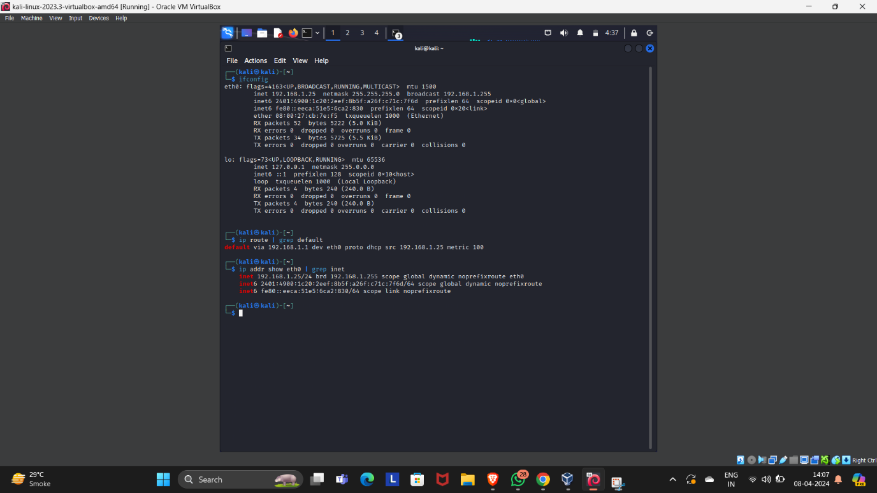

### Using Nmap to Discover Connected Devices:

1. **Install Nmap**:
   * If you don’t already have Nmap installed, you can do so using the following commands:
     + On Ubuntu: sudo apt-get install nmap
     + On Fedora: sudo dnf install nmap
     + On Manjaro: sudo pacman -Syu nmap
2. **Find Your IP Address**:
   * Use the ip addr command to discover your Linux computer’s IP address.
   * Look for the label “inet” in the output. For example, if your IP address is “192.168.4.25,” the subnet mask is “/24” (255.255.255.0).
3. **Run Nmap**:
   * Execute the following Nmap command to find devices connected to the local network:
   * nmap -sn 192.168.0.0/24
     + The -sn option skips port scanning and focuses on host discovery.
     + If you want to include MAC addresses, run the command as superuser:
     + sudo nmap -sn 192.168.0.0/24
4. **Interpreting the Output**:
   * The output will display IP addresses of connected devices.
   * If you see any unknown devices, investigate further to ensure network security

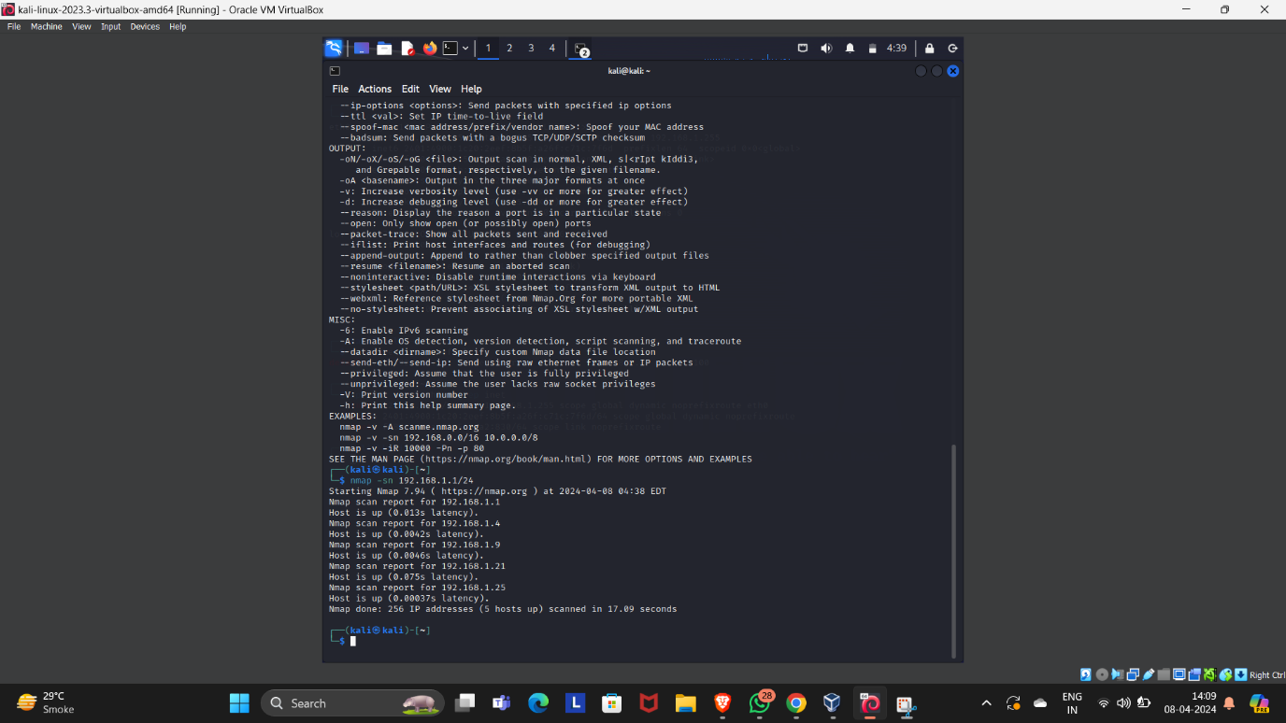

Q5. Perform privilege escalation on the Metasploitable machine and provide a detailed description of the process you used to achieve this. Explain how you gained elevated privileges.

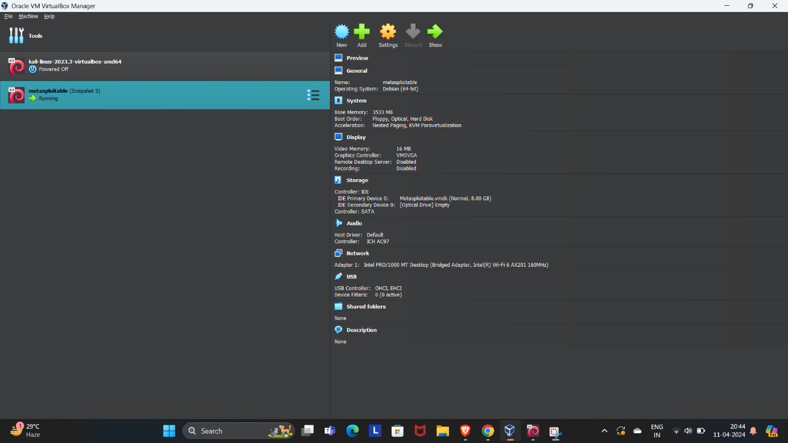

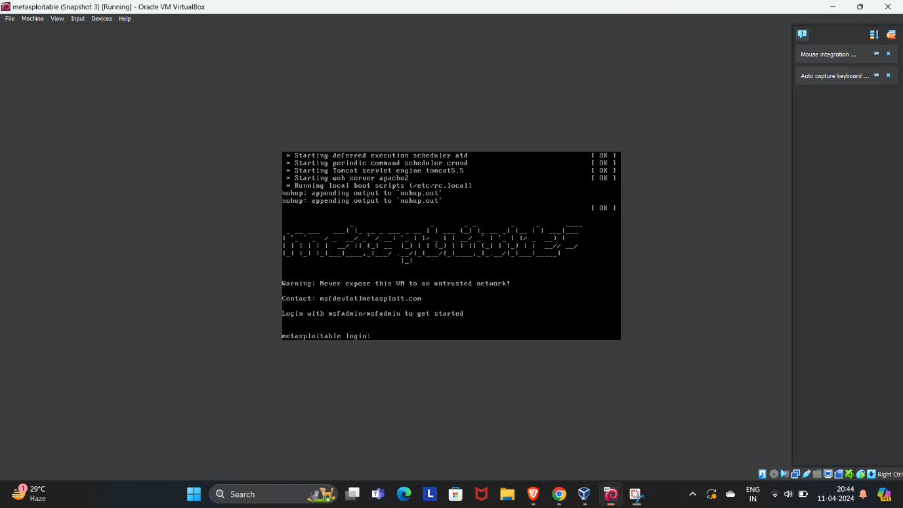

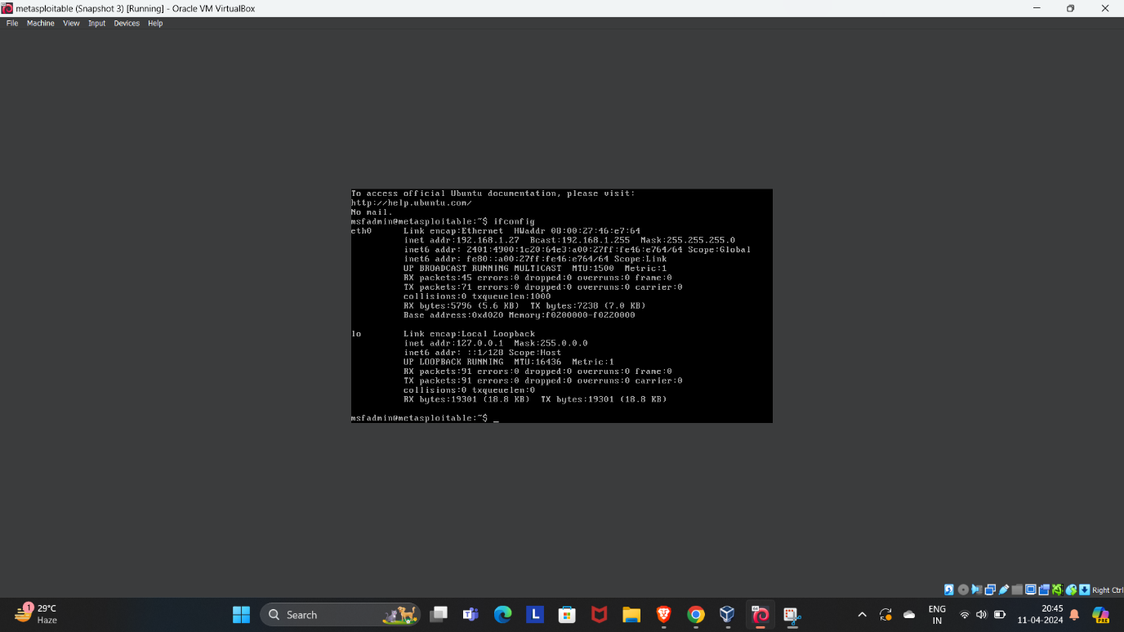

Certainly! Privilege escalation is a critical step in penetration testing, and I’ll guide you through the process of gaining elevated privileges on the Metasploitable machine. Let’s break it down step by step:

1. **Initial Access**:
   * We’ve already compromised the Metasploitable virtual machine by exploiting unpatched vulnerabilities.
   * Our initial access is at a low privilege user level.

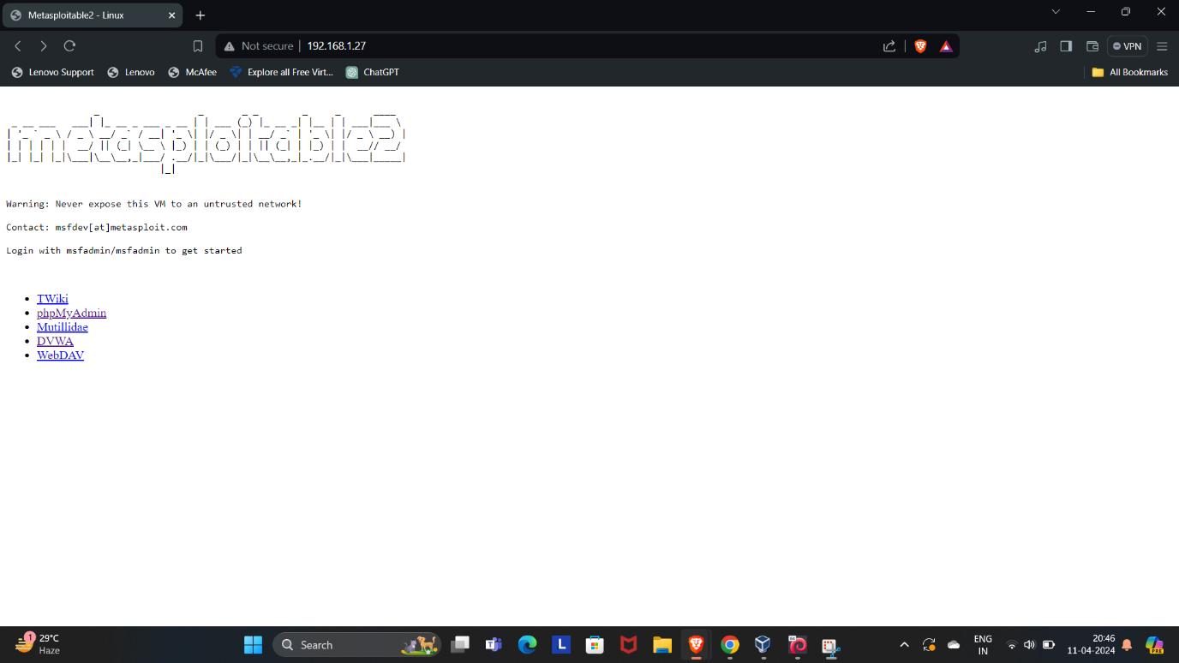

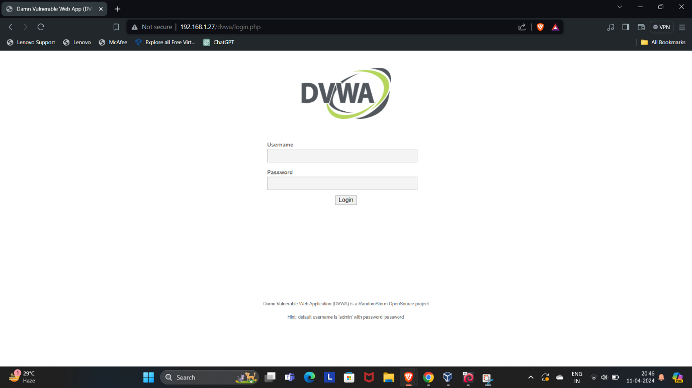

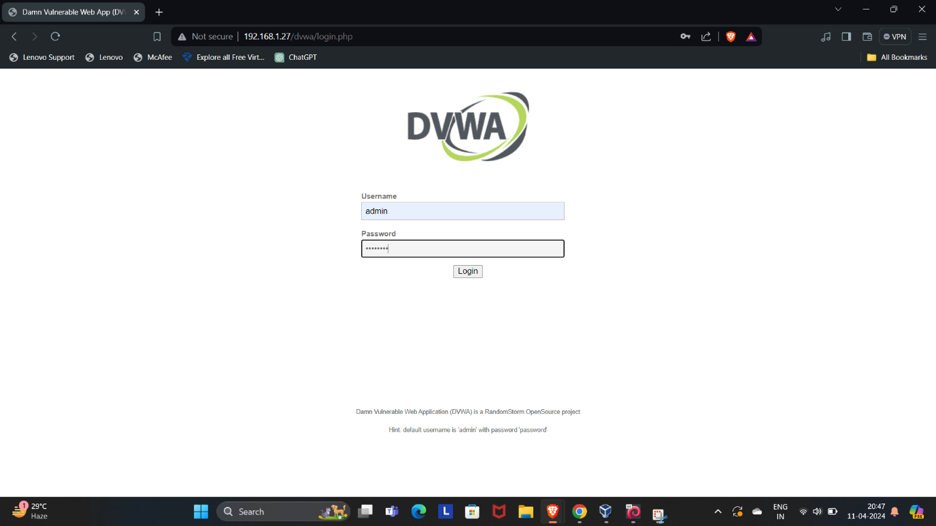

1. **Network Configuration**:
   * We ensure that both our Kali Linux machine and the Metasploitable machine are on the same subnet.
   * We verify this by running the ifconfig command on both machines.
2. **Service Enumeration**:
   * We perform an Nmap scan on the Metasploitable machine to identify the network services running.
   * The command is: sudo nmap -sV -O 172.20.10.3.
   * The scan reveals a list of accessible services.

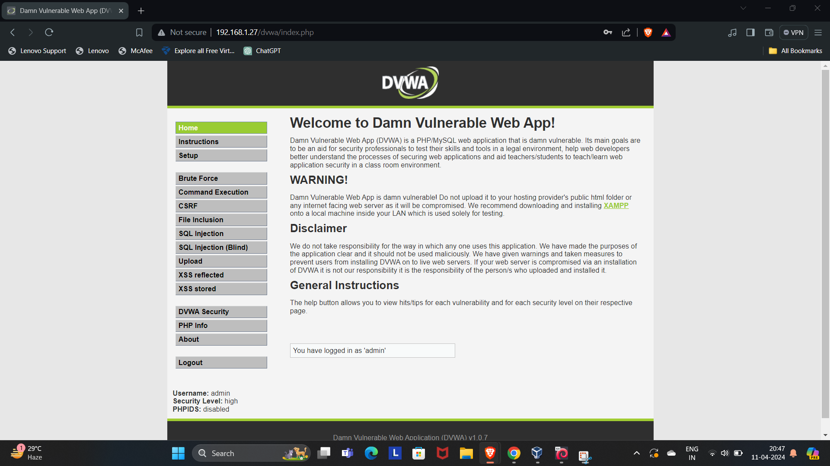

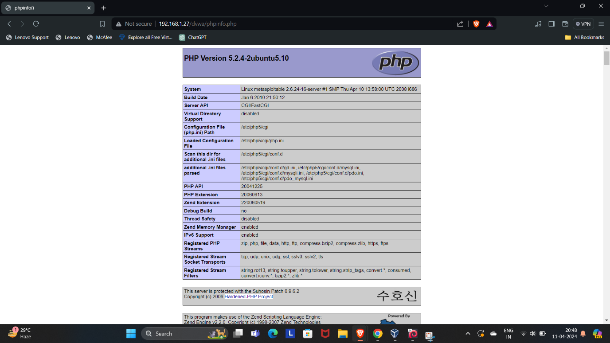

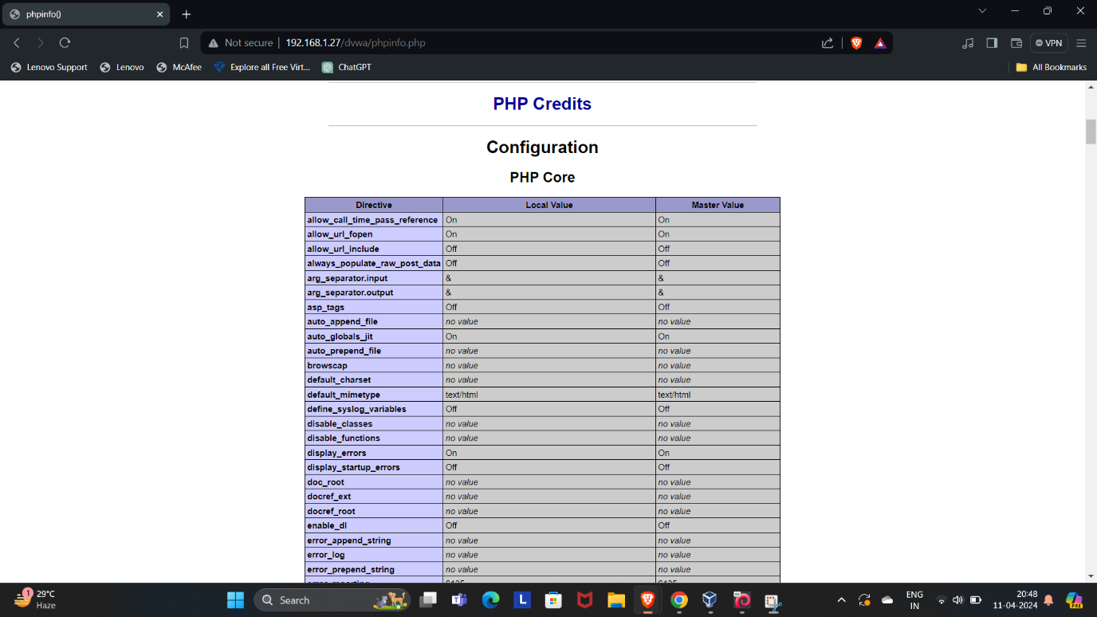

**4.Exploiting vsftpd 2.3.4 Backdoor**:

* + We use Metasploit to exploit the vsftpd 2.3.4 backdoor vulnerability.
  + Within Metasploit, we select the exploit module: use exploit/unix/ftp/vsftpd_234_backdoor.
  + We set the target IP address: set RHOST 172.20.10.3.
  + Finally, we execute the exploit: exploit.
  + This provides us with a command shell on the Metasploitable machine.

**5.Privilege Escalation**:

* + We explore the system using commands like pwd and ls -l.
  + To escalate privileges, we navigate to the root directory: cd /.
  + We verify that we have full access by checking files and folders.

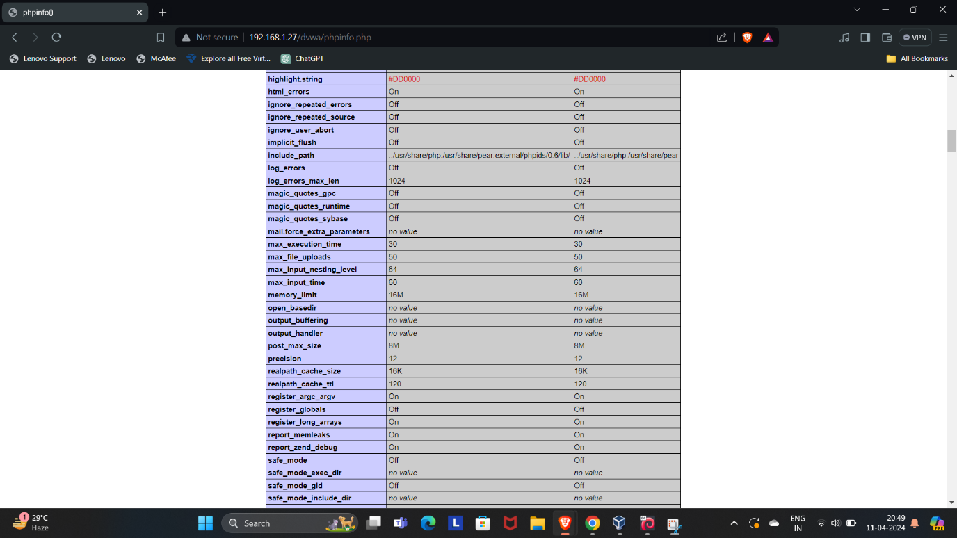

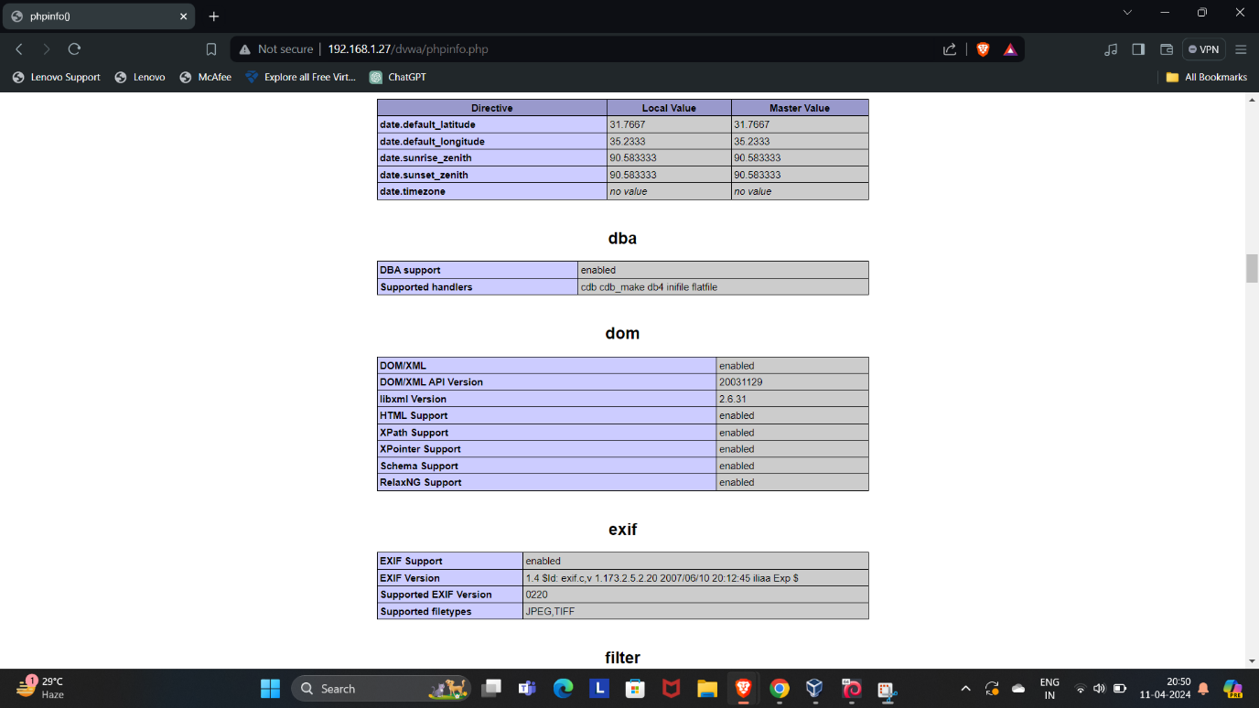

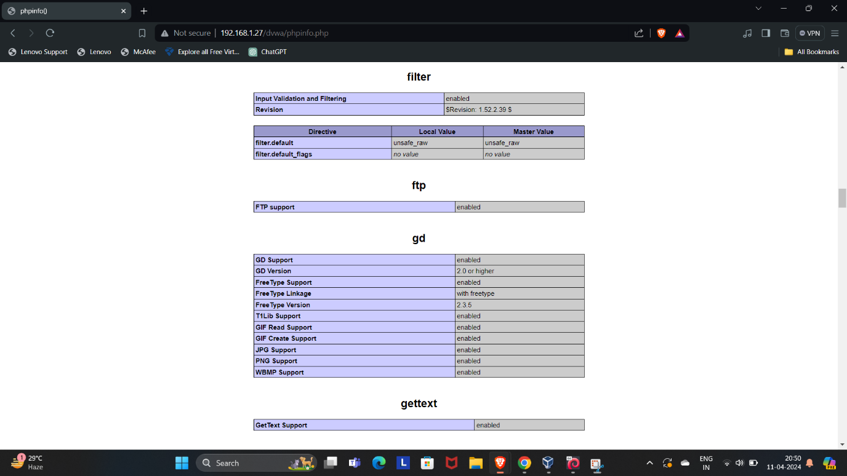

**6.Achieving Root-Level Administrative Control**:

* + By exploiting the vsftpd backdoor, we’ve escalated from low privilege user access to full system root level administrative control.
  + With root privileges, we can perform advanced operations and manipulate the system as needed.

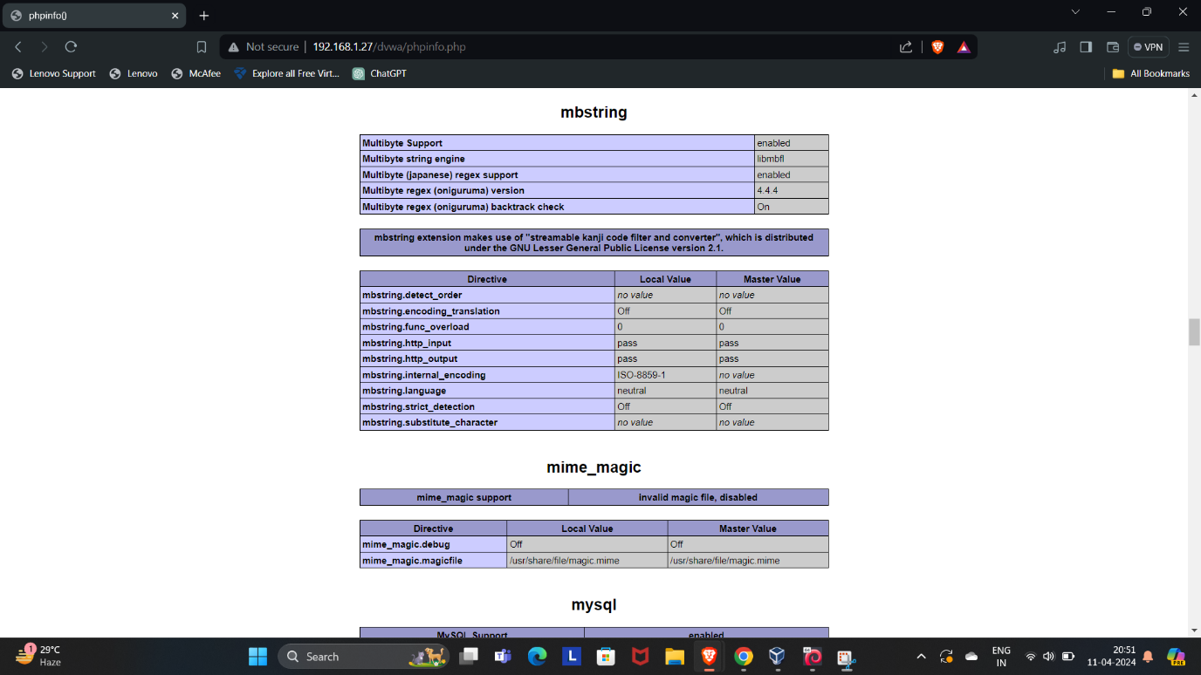

To perform an admin login on the Damn Vulnerable Web Application (DVWA), you would typically follow these steps:

1. **Access DVWA Login Page**:
   * Open a web browser and navigate to the DVWA login page, which is usually located at <http://[DVWA-IP]/login.php>.
2. **Enter Default Credentials**:
   * Use the default credentials to log in:
     + **Username**: admin
     + **Password**: password

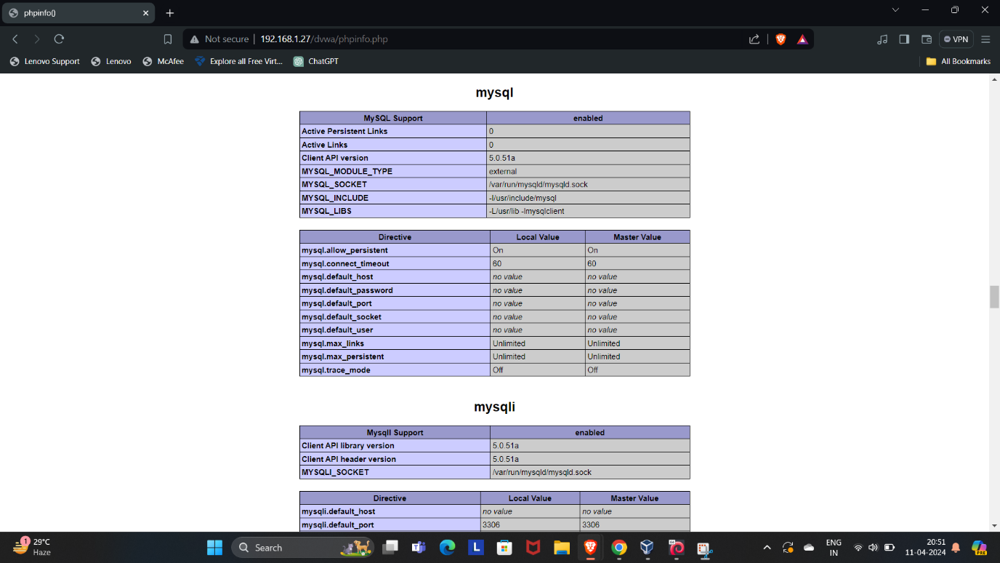

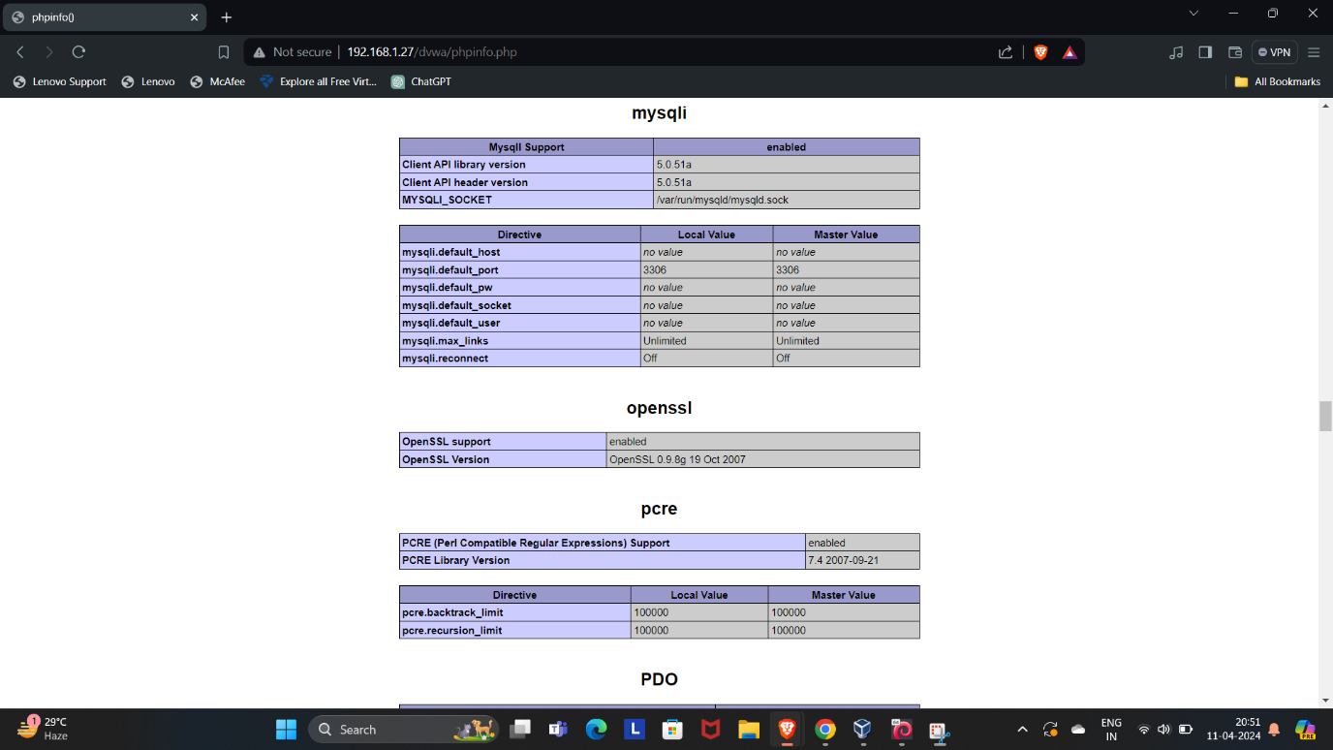

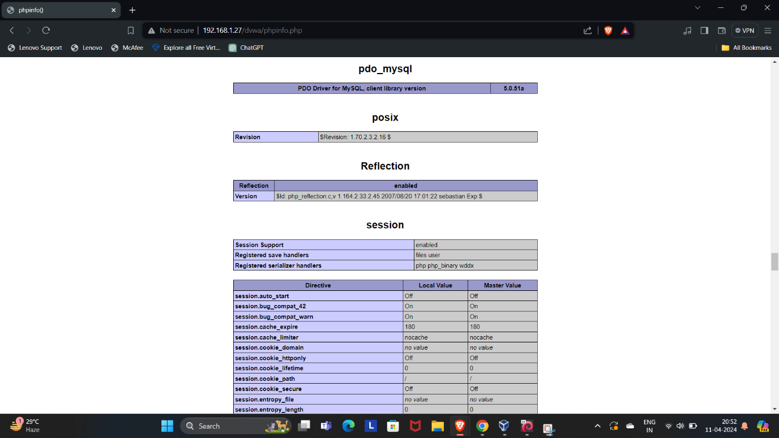

1. **Login**:
   * After entering the credentials, click the ‘Login’ button to access the DVWA dashboard.
2. **Security Level**:
   * Once logged in, you can set the security level of DVWA to low, medium, or high, depending on your testing scenario.
3. **Start Testing**:
   * With admin access, you can now start performing various security tests and exercises available within DVWA.

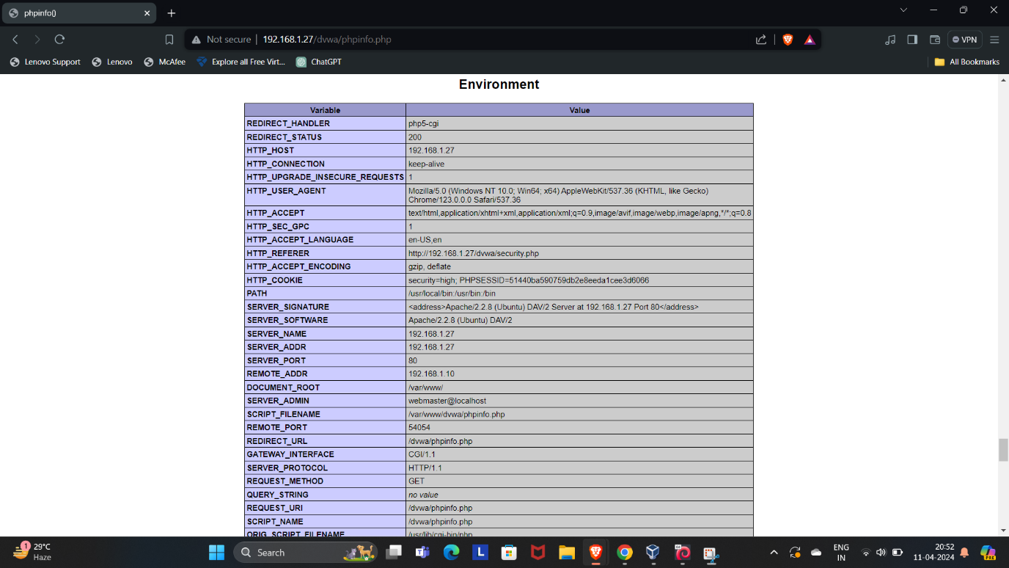

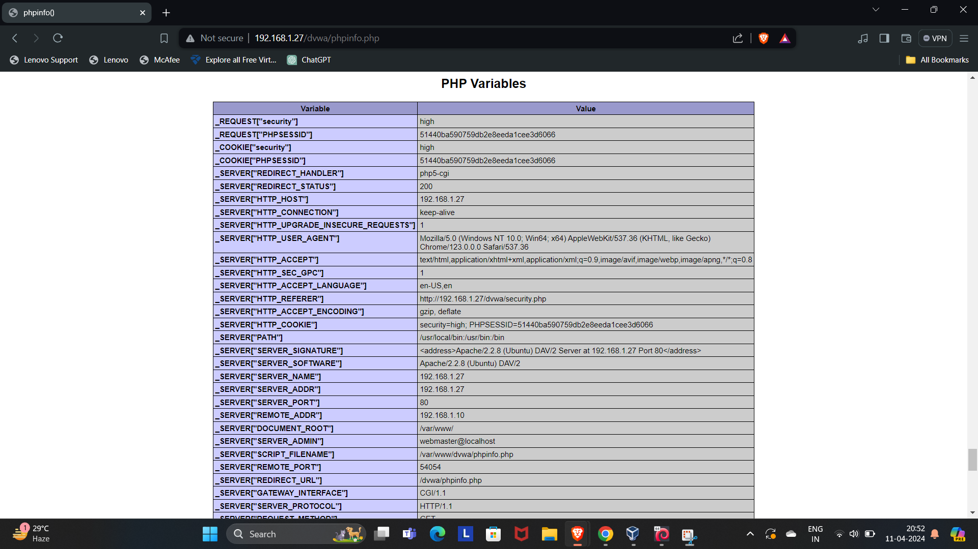

Remember, DVWA is designed to be vulnerable and should only be used in a controlled environment for educational purposes. Ensure that you have permission to access and test the DVWA instance you are working with to avoid any legal issues.

Q6.Employ a password cracking tool such as John the Ripper or Hydra to illustrate how a weak password can be compromised. Provide a detailed explanation of the step-by-step process you followed to achieve this.

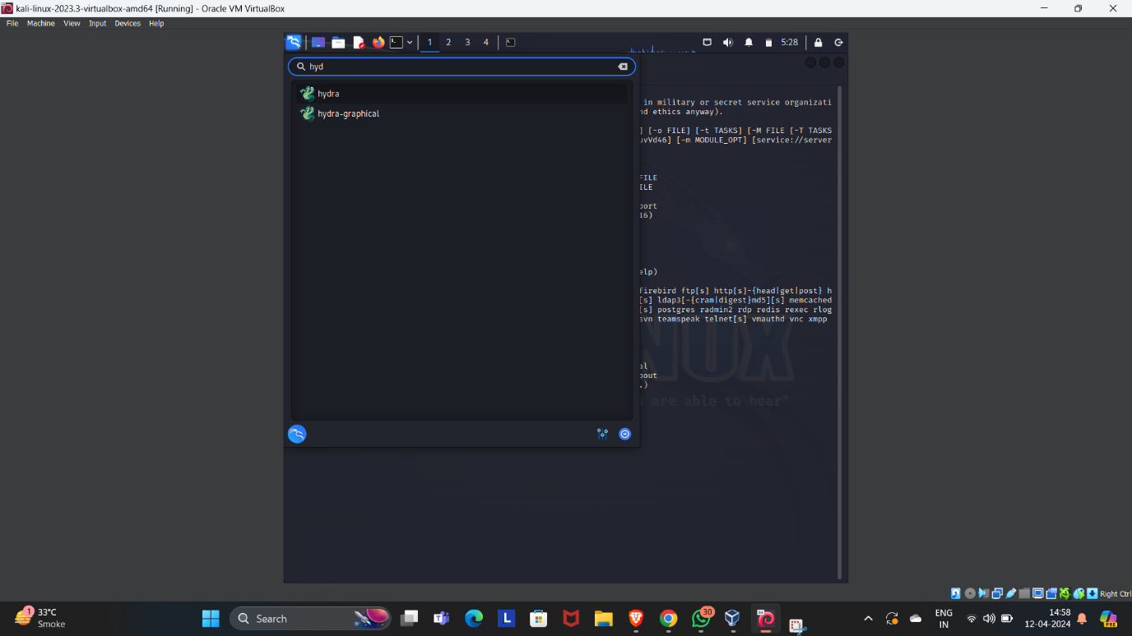

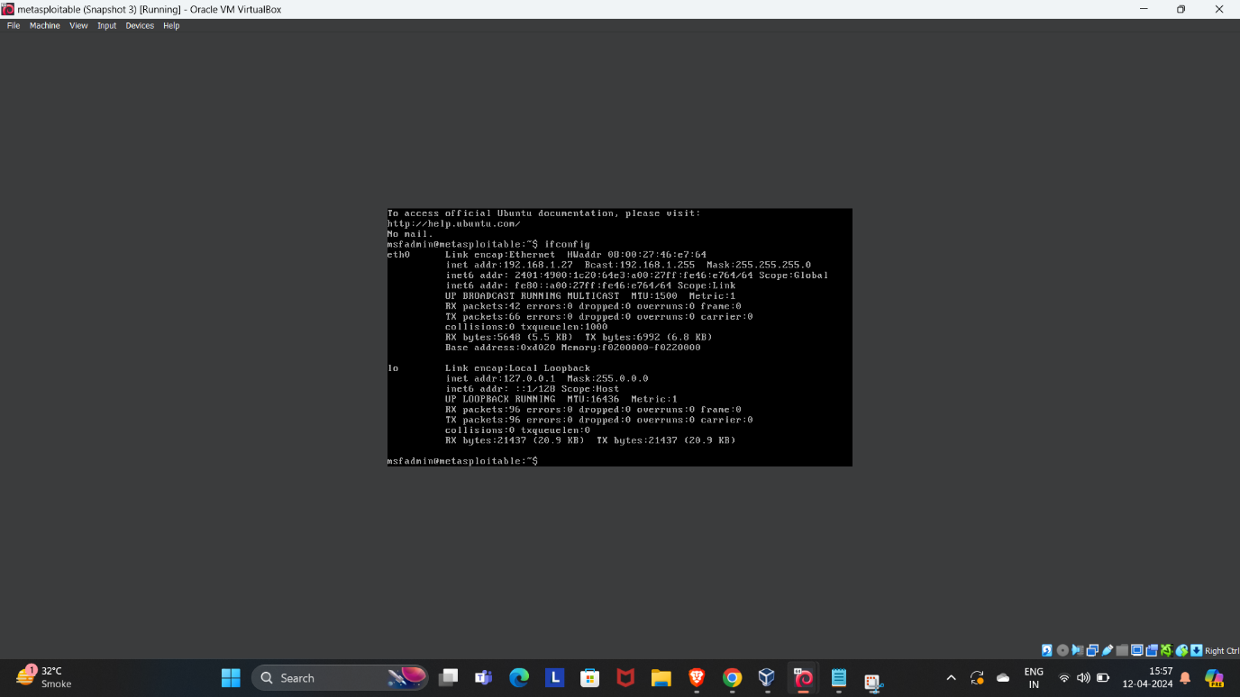

Certainly! Let’s explore how **Hydra**, a powerful password-cracking tool, can be used to compromise a weak password. Before we proceed, please note that this demonstration is for educational purposes only, and you should always obtain permission before attempting any security testing on systems.

1. **What is Hydra?**
   * **Hydra** is a versatile brute-forcing tool that assists penetration testers and ethical hackers in cracking passwords for various network services.
   * [It can perform rapid dictionary attacks against more than 50 protocols, including telnet, FTP, HTTP, HTTPS, SMB, and databases](https://www.freecodecamp.org/news/how-to-use-hydra-pentesting-tutorial/)[1](https://www.freecodecamp.org/news/how-to-use-hydra-pentesting-tutorial/).

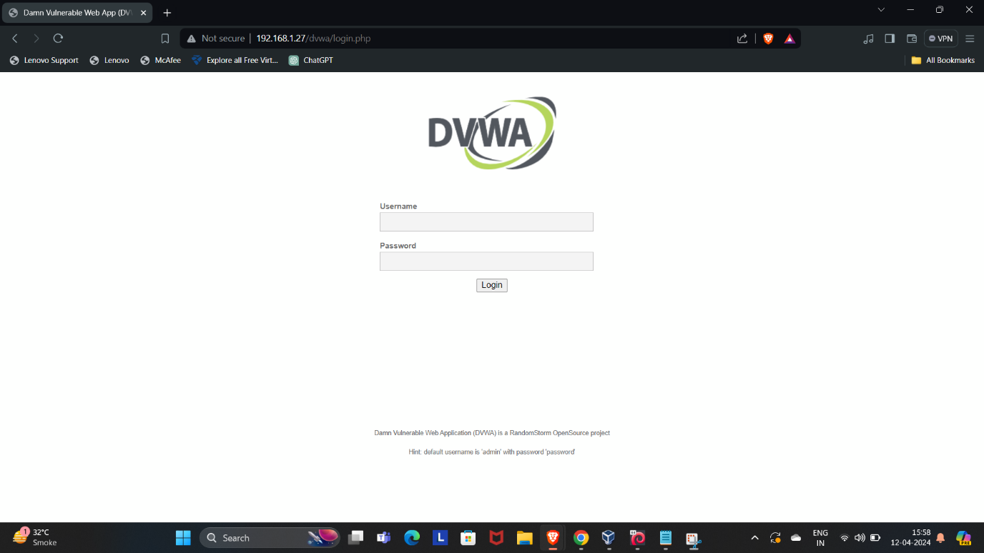

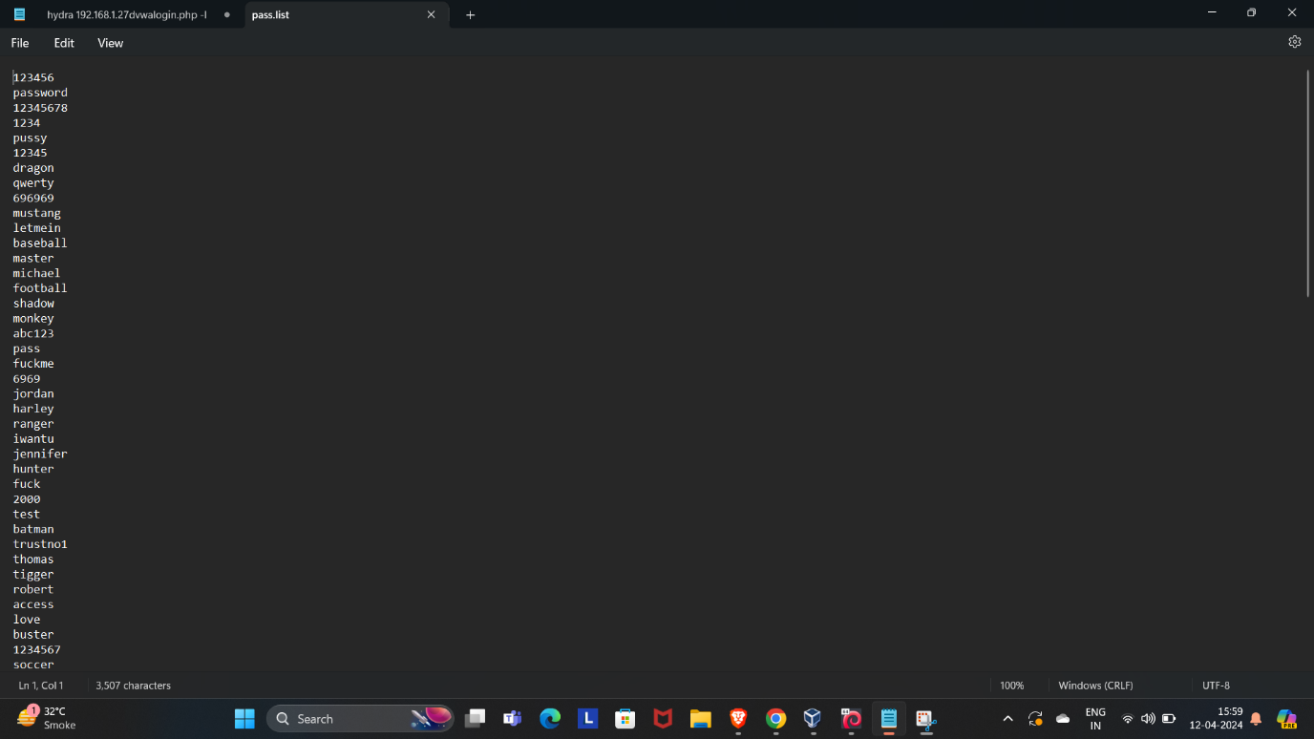

1. **Installation of Hydra:**
   * If you’re using **Kali Linux** or **Parrot OS**, Hydra comes pre-installed. You can start using it right away.
   * On **Ubuntu**, install Hydra using the following command:
   * $ apt install hydra
   * For **Mac**, you can find Hydra under Homebrew:
   * $ brew install hydra
2. **Working with Hydra:**
   * Let’s explore common formats and options for brute-forcing usernames and passwords.

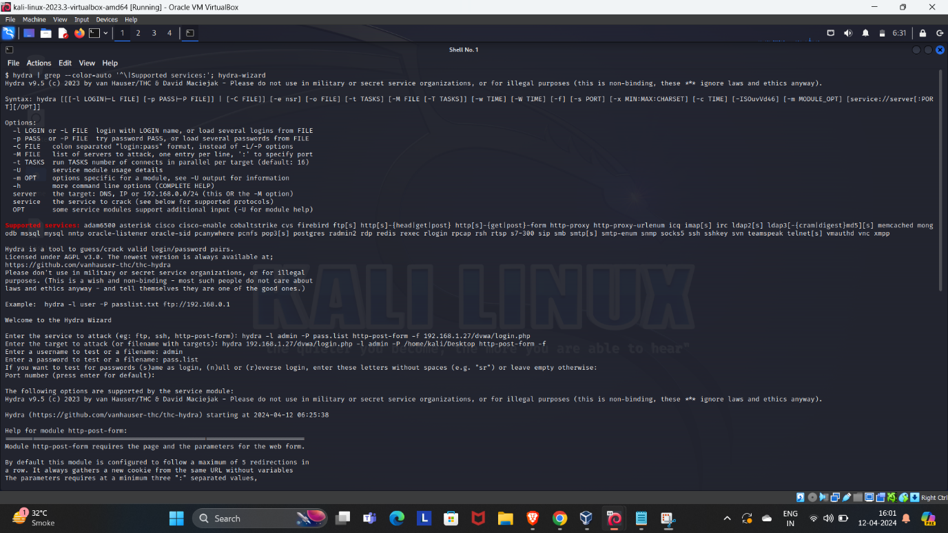

1. **Single Username/Password Attack:**
   * Suppose we have a user named **“molly”** with a password of **“butterfly”** hosted at IP address **10.10.137.76**.
   * We can use Hydra to test these credentials for SSH:
   * $ hydra -l molly -p butterfly 10.10.137.76 ssh
   * [If successful, the result will indicate a valid login](https://www.freecodecamp.org/news/how-to-use-hydra-pentesting-tutorial/)[1](https://www.freecodecamp.org/news/how-to-use-hydra-pentesting-tutorial/).
2. **Password Spraying Attack:**
   * In scenarios where we know a password but not the associated username, we can perform a password spray attack.
   * This involves trying the known password against multiple usernames.
   * For example, if we know the password **“summer2024”**, we can use Hydra to test it against various usernames on a specific service.

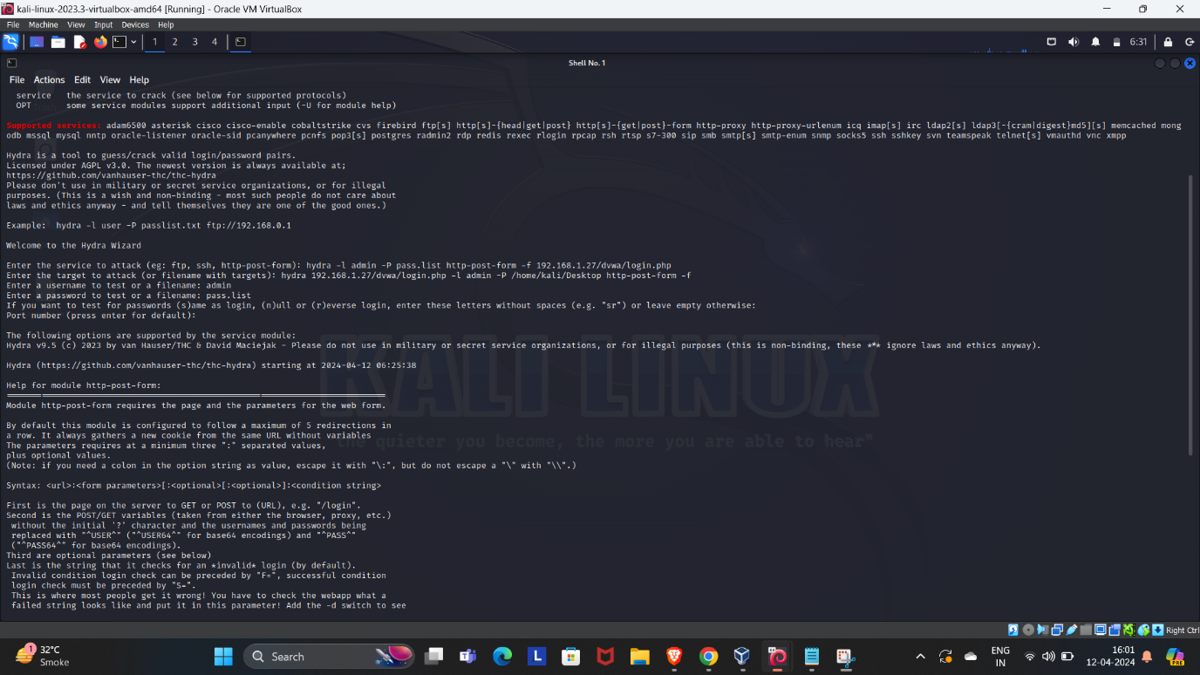

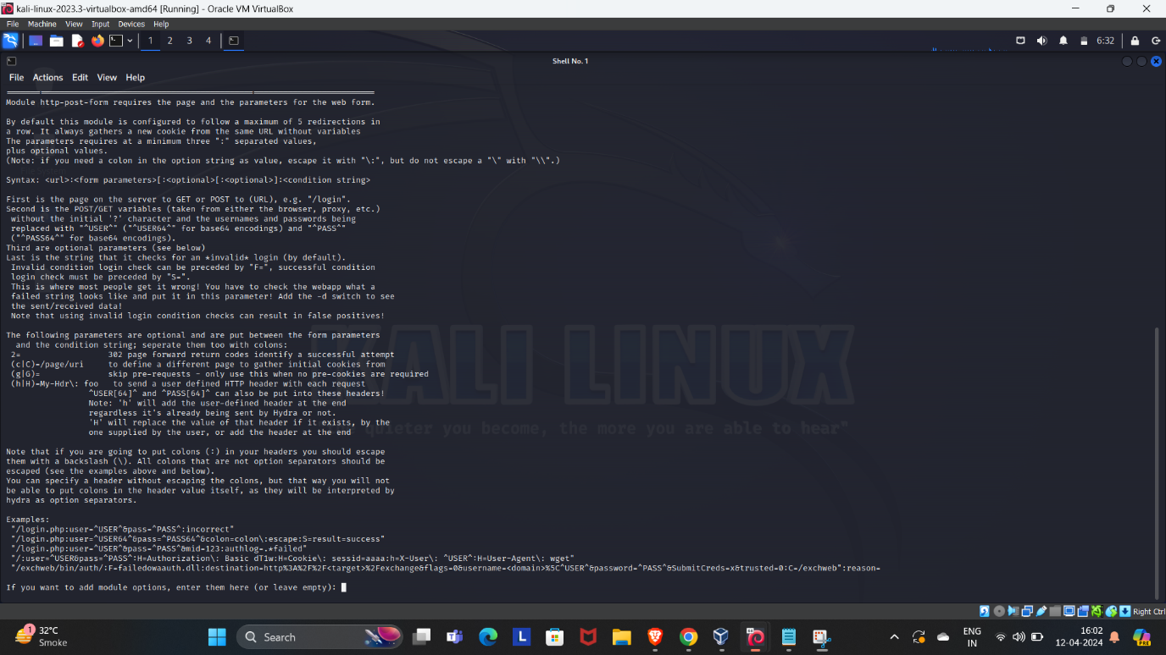

1. **Dictionary Attacks:**
   * Hydra can also perform dictionary attacks by trying a list of common passwords against a target.
   * For instance, you can use a wordlist (dictionary) containing potential passwords and let Hydra iterate through them.

Remember to always follow ethical guidelines and obtain proper authorization before conducting any security testing. Unauthorized use of such tools can have legal consequences.

Q7. Conduct a simulated phishing attack in a wide area network (WAN) environment using any suitable tool to demonstrate potential risks, specifically focusing on accessing webcams. Provide a detailed account of the steps you took during the simulation.

Additionally, explain effective strategies for educating and raising awareness among employees about safeguarding against such types of phishing attacks.



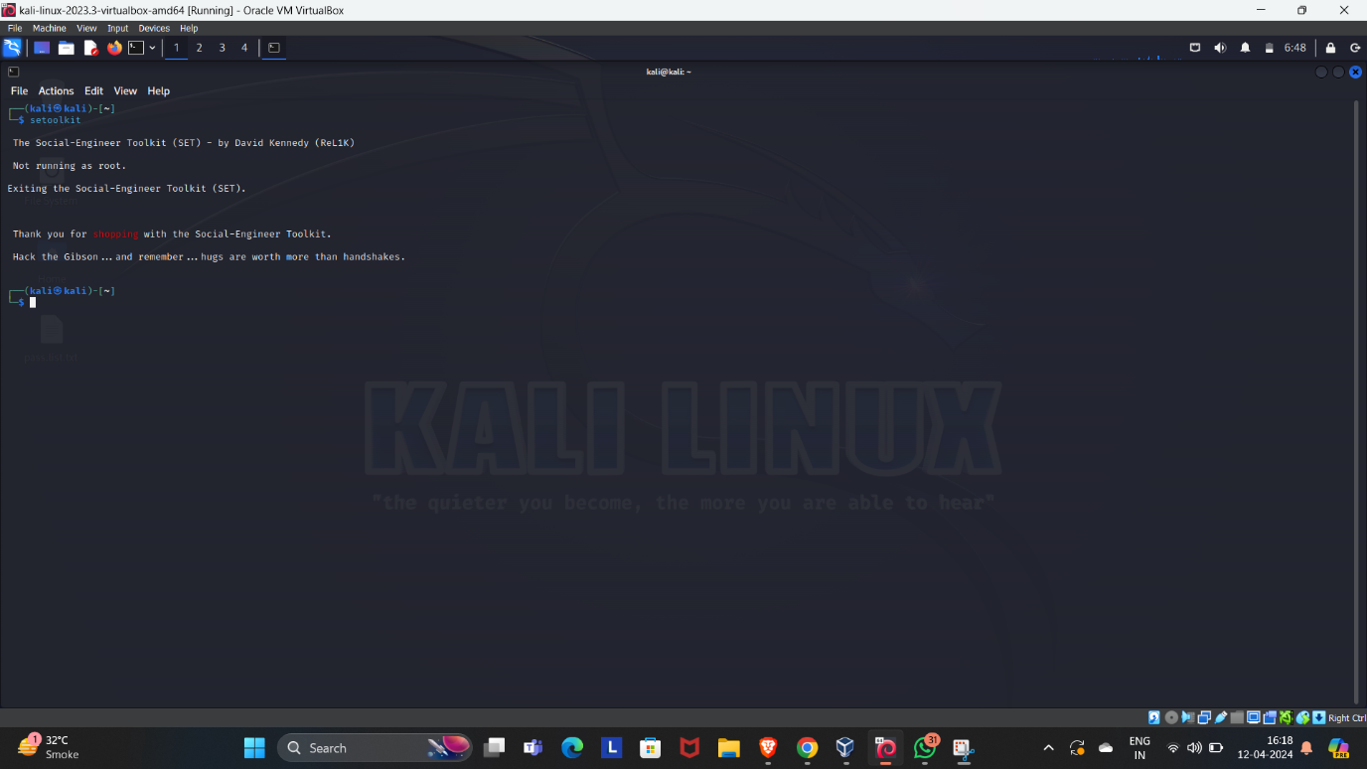

To conduct a simulated phishing attack using the Social Engineering Toolkit (SET), you can follow these steps:

1. Open SET: Open SET by typing setoolkit in the terminal.

2. Select the phishing attack option: Select option 1, "Social-Engineering Attacks," and then select option 2, "Website Attack Vectors."

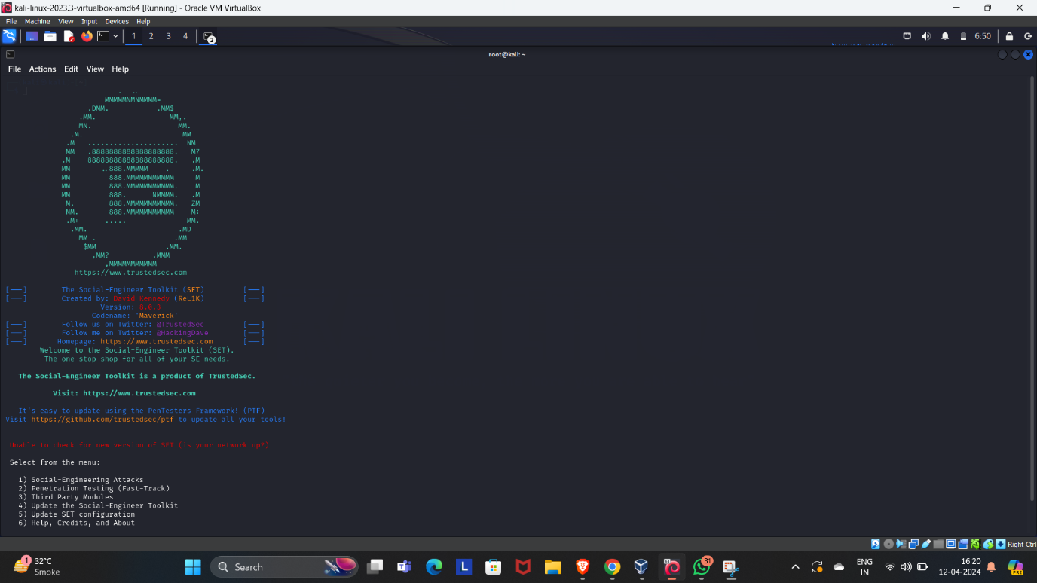

3. Select the credential harvester attack: Select option 2, "Credential Harvester Attack Method," to create a fake login page that captures the user's login credentials.

4. Select the website template: Select the website template that you want to use for the fake login page.

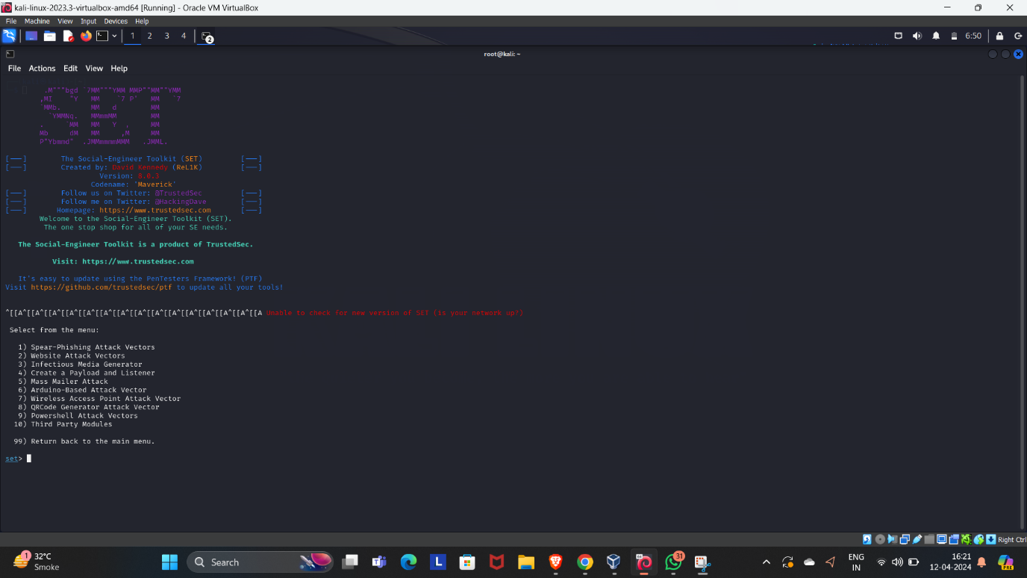

5. Set up the IP address and port: Enter the IP address and port number that you want to use for the fake login page.

6. Create the phishing email: Create a phishing email that appears to be from a trusted source, such as a bank or a social media platform. The email should contain a link to the fake login page that you created in the previous step.

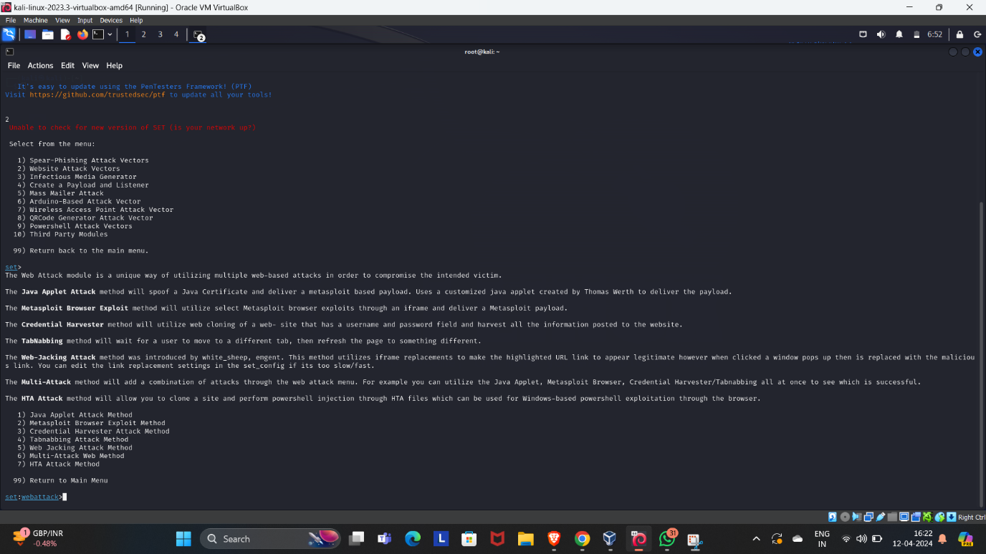

7. Send the phishing email: Once the phishing email is ready, send it to the target users.

8. Wait for the user to click the link: When the user clicks the link in the phishing email, they will be taken to the fake login page.

9. Capture the user's login credentials: When the user enters their login credentials on the fake login page, capture them and store them for later use.



10. Use the captured credentials to access the user's webcam: Once you have the user's login credentials, use them to log in to their account. Once you are logged in, look for any vulnerabilities that may allow you to access their webcam.

11. Record the user's webcam feed: Once you have access to the user's webcam, record their webcam feed.

By following these steps, you can demonstrate the potential risks associated with phishing attacks, particularly those that aim to gain unauthorized access to webcams using the Social Engineering Toolkit. It is important to note that unauthorized access to webcams is illegal and should never be performed without proper authorization.



To effectively educate and raise awareness among employees about safeguarding against phishing attacks, you can follow these strategies:

1. Conduct regular training sessions: Conduct regular training sessions to educate employees about the risks associated with phishing attacks and how to identify and avoid them.

2. Use real-life examples: Use real-life examples of phishing attacks to help employees understand the potential risks and consequences.

3. Implement email filtering: Implement email filtering to help prevent phishing emails from reaching employees' inboxes.





4. Use multi-factor authentication: Use multi-factor authentication to add an extra layer of security to employee accounts.

5. Encourage employees to report suspicious emails: Encourage employees to report suspicious emails to the IT department or security team.

6. Implement a security policy: Implement a security policy that outlines the steps employees should take to protect themselves and the organization from phishing attacks.

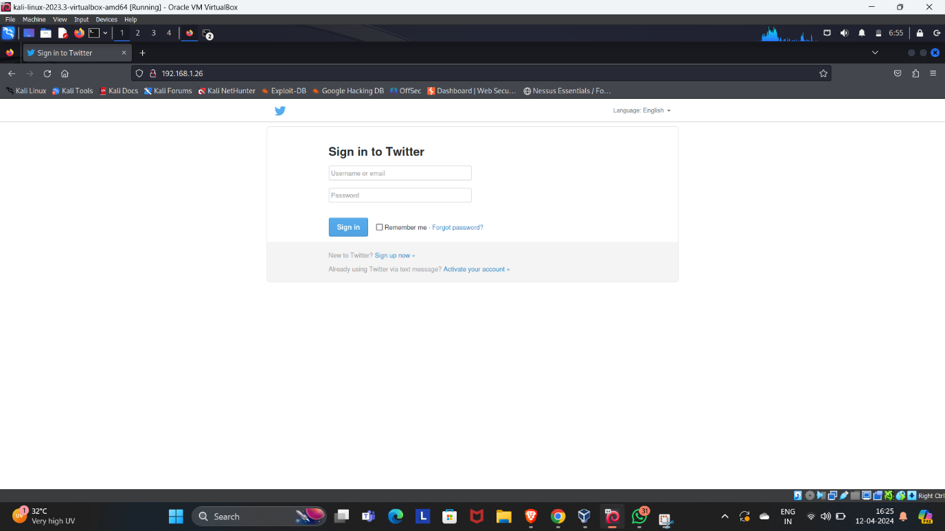

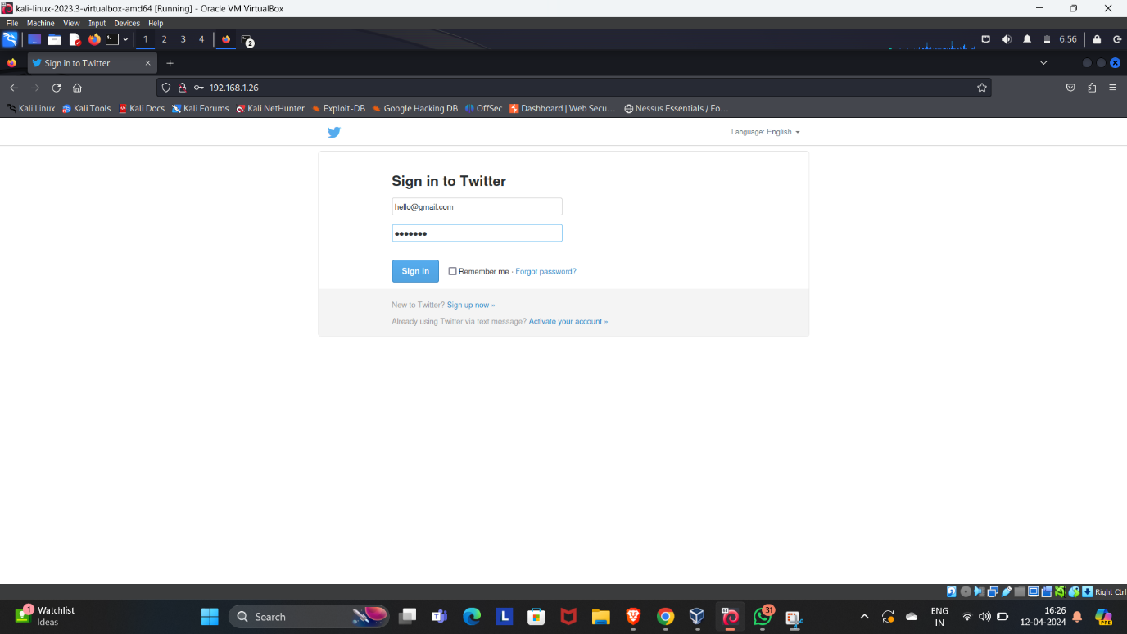

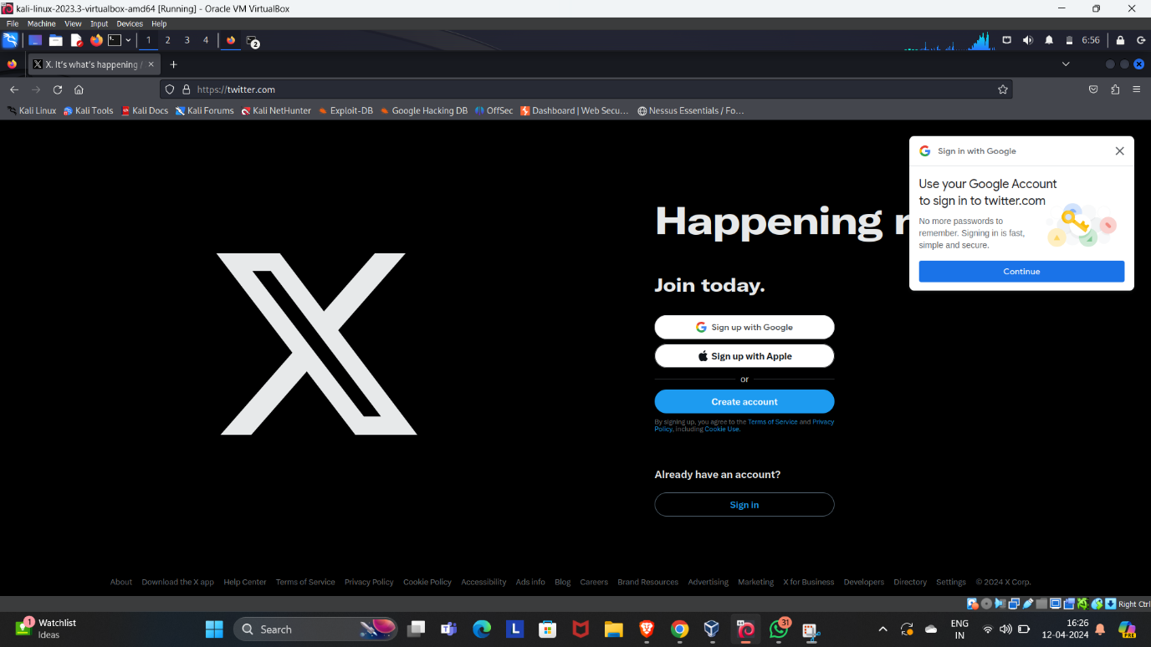

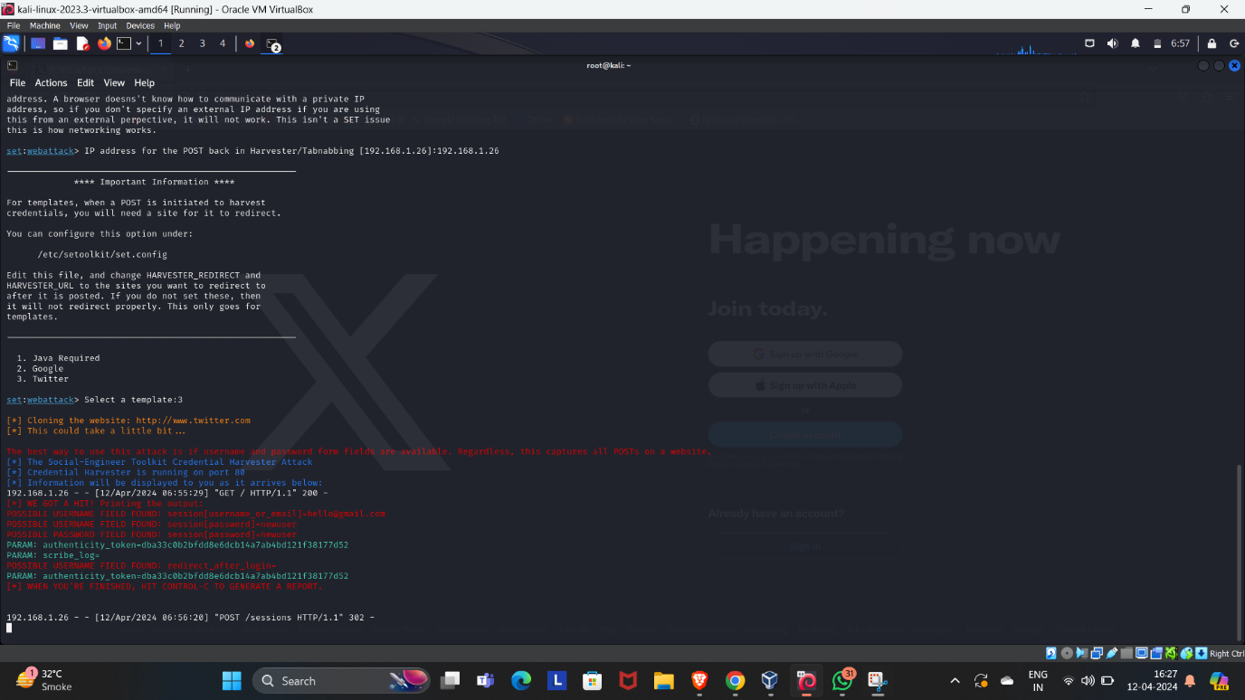

7. Regularly test employees: Regularly test employees to ensure that they are following the security policy and are able to identify and avoid phishing attacks.

By following these strategies, you can effectively educate and raise awareness among employees about safeguarding against phishing attacks. It is important to note that employee education and awareness is a critical component of any organization's cybersecurity strategy.

Q8. Scenario:

You work for a medium-sized e-commerce company that handles a large volume of customer data, including personal Information and payment details. The company's website and backend systems are crucial for operations.

One morning, an employee notices unusual activity on the company's internal network monitoring system. After further investigation, it becomes evident that an unauthorized user has gained access to the company's customer database. The security team suspects a potential data breach.

Task:

A

As an intern in the cybersecurity and ethical hacking domain, your task is to develop an incident response plan to address this situation. The plan should outline the steps to take in case of this security incident.

Incident Response Plan:

1. Containment:

* Isolate the affected systems: Immediately isolate the affected systems from the network to prevent further damage and data exfiltration.

* Change passwords: Change the passwords for all accounts that have access to the affected systems.

* Disable unnecessary services: Disable any unnecessary services running on the affected systems.

* Implement firewall rules: Implement firewall rules to block any suspicious traffic.

2. Eradication:

* Identify the source of the breach: Identify the source of the breach and determine how the unauthorized user gained access to the company's customer database.

* Remove malware: Remove any malware or malicious code from the affected systems.

* Patch vulnerabilities: Patch any vulnerabilities that were exploited to gain access to the affected systems.

3. Recovery:

* Restore systems: Restore the affected systems from a clean backup.

* Test systems: Test the restored systems to ensure that they are functioning properly and that the vulnerabilities have been addressed.

* Monitor systems: Monitor the restored systems for any further suspicious activity.

4. Lessons learned:

* Review incident: Review the incident to identify any lessons learned and areas for improvement.

* Update policies: Update the company's security policies and procedures based on the lessons learned.

* Train employees: Train employees on the updated policies and procedures to prevent future incidents.

Note: This incident response plan is a general outline and may need to be customized based on the specific circumstances of the data breach. It is important to have a well-documented incident response plan in place before a security incident occurs to ensure a timely and effective response.

Q9. Provide an in-depth explanation of the distinctions between WEP, WPA, WPA2, and WPA3 in the context of wireless networking. Additionally, please share your recommendation for the most secure option among them and elucidate the reasons behind your choice.

WEP (Wired Equivalent Privacy) is a security protocol used in wireless networks that was introduced in 1997 as part of the IEEE 802.11 standard. WEP uses a symmetric encryption algorithm to protect wireless communication, but it has been found to have several weaknesses that make it vulnerable to attacks. Some of the weaknesses of WEP include the use of a static key, weak encryption algorithms, and the lack of proper key management.

WPA (Wi-Fi Protected Access) is a security protocol that was introduced in 2003 as a replacement for WEP. WPA uses a more robust encryption algorithm called TKIP (Temporal Key Integrity Protocol) and provides better key management than WEP. However, WPA still has some vulnerabilities, such as the use of a weak initialization vector and the lack of support for advanced encryption algorithms.

WPA2 (Wi-Fi Protected Access 2) is a security protocol that was introduced in 2004 as an improvement over WPA. WPA2 uses a stronger encryption algorithm called AES (Advanced Encryption Standard) and provides better key management than WPA. WPA2 also supports the use of CCMP (Counter Mode with Cipher Block Chaining Message Authentication Code Protocol) for data encryption, which provides better security than TKIP.

WPA3 (Wi-Fi Protected Access 3) is the latest security protocol for wireless networks, introduced in 2018. WPA3 provides several improvements over WPA2, including better encryption algorithms, improved key management, and support for forward secrecy. WPA3 also includes a new feature called "Simultaneous Authentication of Equals" (SAE), which provides better protection against password-guessing attacks.

In summary, WEP is an outdated and insecure security protocol that should be avoided. WPA provides some improvements over WEP but still has vulnerabilities. WPA2 is a more secure protocol that provides better encryption and key management than WPA. WPA3 is the latest and most secure protocol, providing several improvements over WPA2 and better protection against password-guessing attacks.

Based on the current state of wireless security, WPA3 is the most secure option for wireless networking. WPA3 provides several improvements over WPA2, including better encryption algorithms, improved key management, and support for forward secrecy.

One of the main advantages of WPA3 is the use of the Dragonfly handshake protocol, which provides better protection against password-guessing attacks. The Dragonfly handshake uses a new key derivation function called Simultaneous Authentication of Equals (SAE), which provides better protection against brute-force attacks and dictionary attacks.

WPA3 also provides better protection against eavesdropping and man-in-the-middle attacks. WPA3 uses a new feature called "Opportunistic Wireless Encryption" (OWE), which provides encryption for open networks without the need for a password. This feature is particularly useful for public Wi-Fi networks, where users may not want to share their passwords.

Overall, WPA3 provides the best security for wireless networks, with improved encryption algorithms, better key management, and stronger protection against password-guessing attacks. While WPA2 is still a secure option, WPA3 provides additional security features that make it the recommended choice for wireless networking.

Q10. Can you provide insight into the methods for accessing a CCTV camera without authorization? If so, kindly describe the process. If not, please elucidate the challenges and difficulties you encounter in attempting to gain unauthorized access.

Accessing a CCTV camera without authorization is a serious security breach and is illegal in most jurisdictions. However, there are several methods that attackers can use to gain unauthorized access to CCTV cameras. Here are some of the most common methods:

1. Default passwords: Many CCTV cameras come with default passwords that are easy to guess or are publicly available online. Attackers can use these default passwords to gain access to the camera's web interface and take control of the camera.

2. Brute force attacks: Attackers can use brute force attacks to guess the camera's password. This involves trying different combinations of usernames and passwords until the correct one is found.

3. Exploiting vulnerabilities: Attackers can exploit vulnerabilities in the camera's firmware or software to gain unauthorized access. This can be done by using publicly available exploits or by discovering new vulnerabilities.

4. Physical access: If an attacker has physical access to the camera, they can connect to it directly using a cable or a wireless connection. This can allow them to bypass any security measures that are in place.

However, gaining unauthorized access to a CCTV camera is not easy, and there are several challenges and difficulties that attackers may encounter. Here are some of the main challenges:

1. Strong passwords: If the camera has a strong and unique password, it can be difficult for attackers to guess or crack it using brute force attacks.

2. Encryption: Many CCTV cameras use encryption to protect the video feed and other sensitive data. If the encryption is strong, it can be difficult for attackers to decrypt the data and gain access to the camera.

3. Security measures: CCTV cameras may have security measures in place, such as firewalls, intrusion detection systems, and access controls. These measures can make it difficult for attackers to gain unauthorized access.

4. Legal consequences: Gaining unauthorized access to a CCTV camera is illegal in most jurisdictions, and attackers may face legal consequences if they are caught.

In summary, while there are several methods for gaining unauthorized access to a CCTV camera, it is not an easy task, and there are several challenges and difficulties that attackers may encounter. It is important to ensure that CCTV cameras are properly secured and that strong passwords and other security measures are in place to prevent unauthorized access.